**Practical no: 1**

**Aim:- Create an Android application to demonstrate the Android Activity**

Code:-

**MainActivity.java**

package com.practical_1;  
import androidx.appcompat.app.AppCompatActivity;  
import android.os.Bundle;  
import android.util.Log;  
public class MainActivity extends AppCompatActivity  
{  
 @Override  
 protected void onCreate(Bundle savedInstanceState)  
 {  
 super.onCreate(savedInstanceState);  
 setContentView(R.layout.activity_main);  
 Log.*d*("lifecycle","onCreate invoked");  
 }  
 @Override  
 protected void onStart()  
 {  
 super.onStart();  
 Log.*d*("lifecycle","onStart invoked");  
 }  
 @Override  
 protected void onResume()  
 {  
 super.onResume();  
 Log.*d*("lifecycle","onResume invoked");  
 }  
 @Override  
 protected void onPause()  
 {  
 super.onPause();  
 Log.*d*("lifecycle","onPause invoked");  
 }  
 @Override  
 protected void onStop()  
 {  
 super.onStop();  
 Log.*d*("lifecycle","onStop invoked");  
 }  
 @Override  
 protected void onRestart()  
 {  
 super.onRestart();  
 Log.d("lifecycle","onRestart  
 invoked");  
 }  
 @Override  
 protected void onDestroy()  
 {  
 super.onDestroy();  
 Log.d("lifecycle","onDestroy  
 invoked");  
 }  
}

Output:-

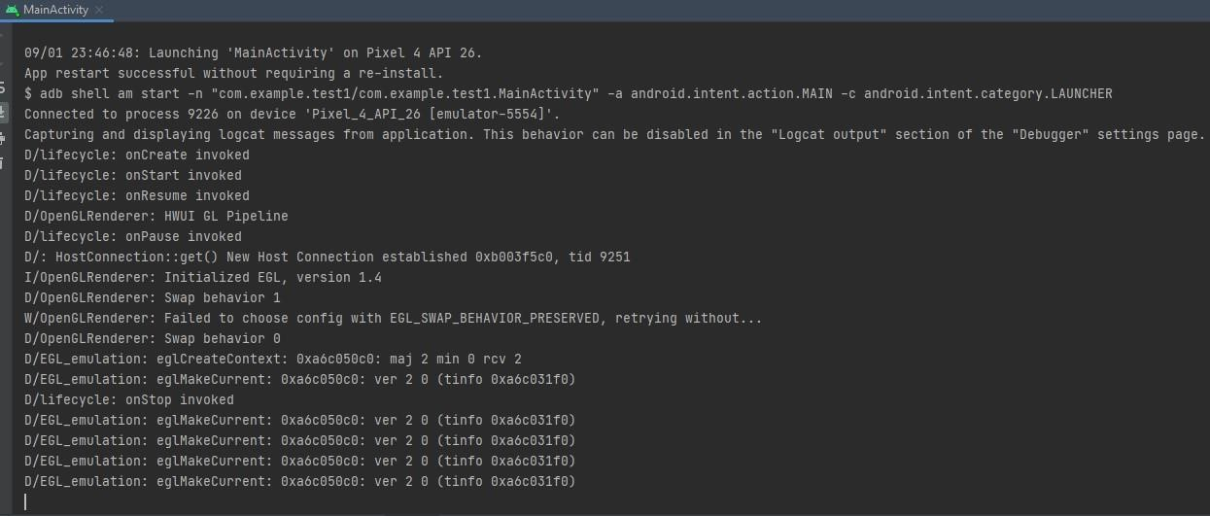

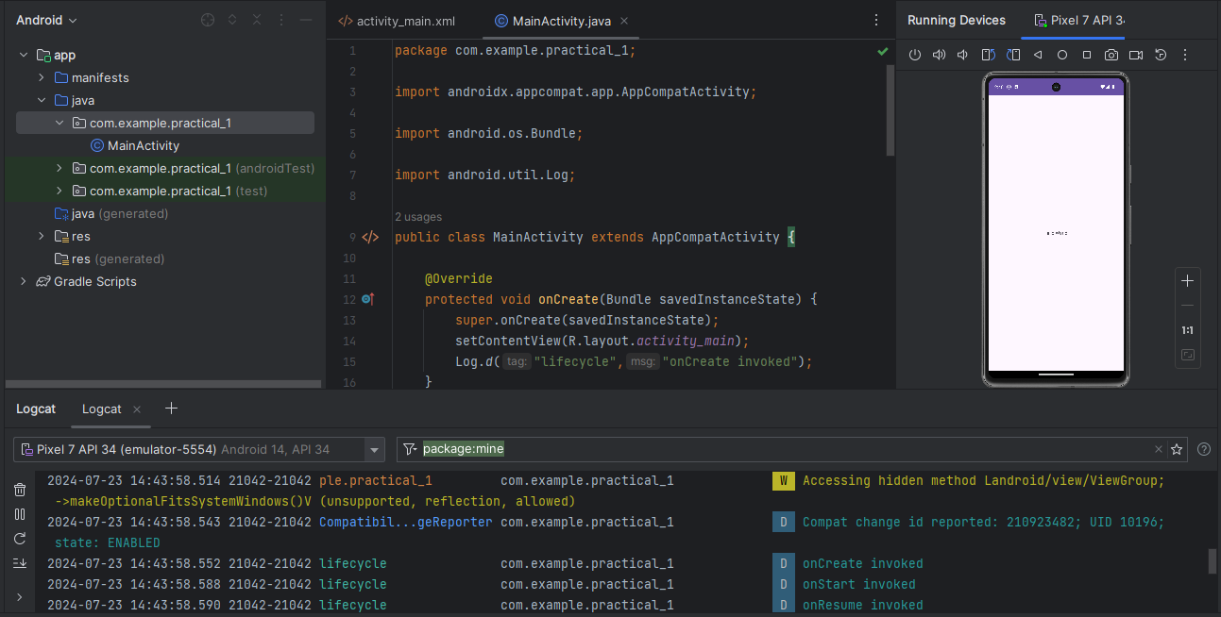

**Practical no: 2**

**Aim:- Create Android Application to get the text from user and display it when button clicks**

Code:-

**Activity_main.xml**

*<?***xml version="1.0" encoding="utf-8"***?>*

<**androidx.constraintlayout.widget.ConstraintLayout xmlns:android[="http://schemas.android.com/apk/res/android"](http://schemas.android.com/apk/res/android) xmlns:app[="http://schemas.android.com/apk/res](http://schemas.android.com/apk/res-auto)-**[**auto"**](http://schemas.android.com/apk/res-auto) **xmlns:tools[="http://schemas.android.com/tools"](http://schemas.android.com/tools) android:layout_width="match_parent" android:layout_height="match_parent" tools:context=".MainActivity"**>

<**TextView android:id="@+id/message" android:layout_width="wrap_content"**

**android:layout_height="wrap_content" android:text="Hello Roll no. 03" android:textSize="20dp" android:textStyle="bold" app:layout_constraintBottom_toBottomOf="parent" app:layout_constraintEnd_toEndOf="parent" app:layout_constraintStart_toStartOf="parent" app:layout_constraintTop_toTopOf="parent" app:layout_constraintVertical_bias="0.37"** />

<**Button android:id="@+id/button"**

**android:layout_width="wrap_content" android:layout_height="wrap_content" android:text="Click me" app:layout_constraintBottom_toBottomOf="parent" app:layout_constraintEnd_toEndOf="parent" app:layout_constraintStart_toStartOf="parent" app:layout_constraintTop_toTopOf="parent"** />

</**androidx.constraintlayout.widget.ConstraintLayout**>

**MainActivity.java**

**package** com.example.practical2;

**import** androidx.appcompat.app.AppCompatActivity;

**import** android.annotation.SuppressLint;

**import** android.os.Bundle;

**import** android.view.View;

**import** android.widget.Button;

**import** android.widget.TextView;

**public class** MainActivity **extends** AppCompatActivity {

**private** TextView **message**; **private** Button **button**;

@SuppressLint(**"MissingInflatedId"**) @Override

**protected void** onCreate(Bundle savedInstanceState) {

**super**.onCreate(savedInstanceState); setContentView(R.layout.***activity_main***);

**button** = (Button) findViewById(R.id.***button***); **message** = (TextView) findViewById(R.id.***message***); **message**.setVisibility(View.***INVISIBLE***);

**button**.setOnClickListener(**new** View.OnClickListener() { @Override

**public void** onClick(View view) {

**message**.setVisibility(View.***VISIBLE***);

}

});

}

}

Output:-

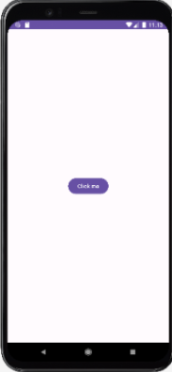 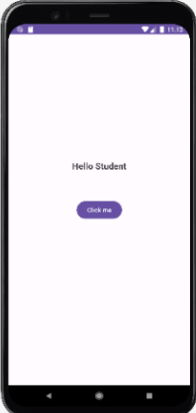

**Practical no: 3**

**Aim:- Create a Simple Calculator in Android Application (+,-,*,/)**

Code:-

**Activity_main.xml**

*<?*xml version="1.0" encoding="utf-8"*?>*<androidx.constraintlayout.widget.ConstraintLayout  
 xmlns:android="http://schemas.android.com/apk/res/android"  
 xmlns:app="http://schemas.android.com/apk/res-auto"  
 xmlns:tools="http://schemas.android.com/tools"  
 android:layout_width="match_parent"  
 android:layout_height="match_parent"  
 tools:context=".MainActivity">  
  
 <EditText  
 android:id="@+id/num1"  
 android:layout_width="0dp"  
 android:layout_height="wrap_content"  
 android:ems="10"  
 android:inputType="number"  
 app:layout_constraintEnd_toEndOf="parent"  
 app:layout_constraintStart_toStartOf="parent"  
 app:layout_constraintTop_toTopOf="parent"  
 app:layout_constraintHorizontal_bias="0.5"  
 android:layout_marginTop="96dp"  
 android:layout_marginStart="16dp"  
 android:layout_marginEnd="16dp"/>  
  
 <EditText  
 android:id="@+id/num2"  
 android:layout_width="0dp"  
 android:layout_height="wrap_content"  
 android:inputType="number"  
 app:layout_constraintEnd_toEndOf="parent"  
 app:layout_constraintStart_toStartOf="parent"  
 app:layout_constraintTop_toBottomOf="@+id/num1"  
 app:layout_constraintHorizontal_bias="0.5"  
 android:layout_marginTop="16dp"  
 android:layout_marginStart="16dp"  
 android:layout_marginEnd="16dp"/>  
  
 <Button  
 android:id="@+id/add"  
 android:layout_width="wrap_content"  
 android:layout_height="wrap_content"  
 android:text="ADD"  
 app:layout_constraintTop_toBottomOf="@+id/num2"  
 app:layout_constraintStart_toStartOf="parent"  
 app:layout_constraintEnd_toStartOf="@+id/sub"  
 android:layout_marginTop="16dp"/>  
  
 <Button  
 android:id="@+id/sub"  
 android:layout_width="wrap_content"  
 android:layout_height="wrap_content"  
 android:text="SUB"  
 app:layout_constraintTop_toBottomOf="@+id/num2"  
 app:layout_constraintStart_toEndOf="@+id/add"  
 app:layout_constraintEnd_toStartOf="@+id/Mul"  
 android:layout_marginTop="16dp"/>  
  
 <Button  
 android:id="@+id/Mul"  
 android:layout_width="wrap_content"  
 android:layout_height="wrap_content"  
 android:text="MUL"  
 app:layout_constraintTop_toBottomOf="@+id/num2"  
 app:layout_constraintStart_toEndOf="@+id/sub"  
 app:layout_constraintEnd_toStartOf="@+id/Div"  
 android:layout_marginTop="16dp"/>  
  
 <Button  
 android:id="@+id/Div"  
 android:layout_width="wrap_content"  
 android:layout_height="wrap_content"  
 android:text="DIV"  
 app:layout_constraintTop_toBottomOf="@+id/num2"  
 app:layout_constraintStart_toEndOf="@+id/Mul"  
 app:layout_constraintEnd_toEndOf="parent"  
 android:layout_marginTop="16dp"/>  
  
 <TextView  
 android:id="@+id/tv3"  
 android:layout_width="wrap_content"  
 android:layout_height="wrap_content"  
 android:text="Result"  
 app:layout_constraintTop_toBottomOf="@+id/add"  
 app:layout_constraintStart_toStartOf="parent"  
 app:layout_constraintEnd_toEndOf="parent"  
 android:layout_marginTop="16dp"/>  
  
 <EditText  
 android:id="@+id/result"  
 android:layout_width="0dp"  
 android:layout_height="wrap_content"  
 android:inputType="none"  
 app:layout_constraintTop_toBottomOf="@+id/tv3"  
 app:layout_constraintStart_toStartOf="parent"  
 app:layout_constraintEnd_toEndOf="parent"  
 android:layout_marginTop="16dp"  
 android:layout_marginStart="16dp"  
 android:layout_marginEnd="16dp"/>  
  
</androidx.constraintlayout.widget.ConstraintLayout>

**MainActivity.java**

package com.example.practical_3;  
  
import androidx.appcompat.app.AppCompatActivity;  
import android.os.Bundle;  
import android.view.View;  
import android.widget.Button;  
import android.widget.EditText;  
import android.widget.TextView;  
import android.widget.Toast;  
  
public class MainActivity extends AppCompatActivity {  
  
 @Override  
 protected void onCreate(Bundle savedInstanceState) {  
 super.onCreate(savedInstanceState);  
 setContentView(R.layout.*activity_main*);  
 }  
  
 public void ADD(View view) {  
 performOperation(view, Operation.*ADD*);  
 }  
  
 public void SUB(View view) {  
 performOperation(view, Operation.*SUBTRACT*);  
 }  
  
 public void MUL(View view) {  
 performOperation(view, Operation.*MULTIPLY*);  
 }  
  
 public void DIV(View view) {  
 performOperation(view, Operation.*DIVIDE*);  
 }  
  
 private void performOperation(View view, Operation operation) {  
 EditText num1 = findViewById(R.id.*num1*);  
 EditText num2 = findViewById(R.id.*num2*);  
 EditText result = findViewById(R.id.*result*);  
  
 try {  
 int x = Integer.*parseInt*(num1.getText().toString());  
 int y = Integer.*parseInt*(num2.getText().toString());  
 float result_num = 0;  
  
 switch (operation) {  
 case *ADD*:  
 result_num = x + y;  
 break;  
 case *SUBTRACT*:  
 result_num = x - y;  
 break;  
 case *MULTIPLY*:  
 result_num = x * y;  
 break;  
 case *DIVIDE*:  
 if (y != 0) {  
 result_num = (float) x / y;  
 } else {  
 Toast.*makeText*(this, "Cannot divide by zero", Toast.*LENGTH_SHORT*).show();  
 return;  
 }  
 break;  
 }  
  
 result.setText(String.*valueOf*(result_num));  
 } catch (NumberFormatException e) {  
 Toast.*makeText*(this, "Please enter valid numbers", Toast.*LENGTH_SHORT*).show();  
 }  
 }  
  
 private enum Operation {  
 *ADD*, *SUBTRACT*, *MULTIPLY*, *DIVIDE* }  
}

Output:-

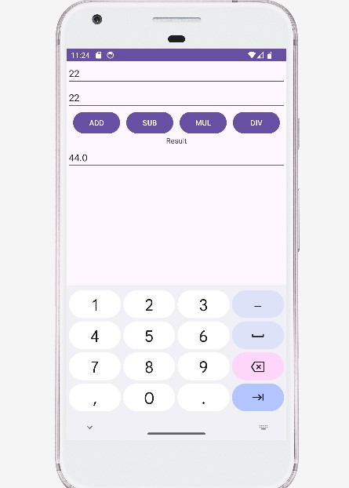

**Practical 4**

**Aim:- Create an Android application to display registration form using UI components.**

Code:-

**MainActivity.java**

package com.example.practical_4;  
  
import androidx.appcompat.app.AppCompatActivity;  
import android.content.Intent;  
import android.os.Bundle;  
import android.view.View;  
import android.widget.Button;  
import android.widget.CheckBox;  
import android.widget.EditText;  
import android.widget.RadioButton;  
import android.widget.RatingBar;  
public class MainActivity extends AppCompatActivity {  
 EditText e1;  
 RadioButton r1, r2;  
 CheckBox c1, c2;  
 Button b1;  
 RatingBar rb1;  
 @Override  
 protected void onCreate(Bundle savedInstanceState) {  
 super.onCreate(savedInstanceState);  
 setContentView(R.layout.*activity_main*);  
 e1 = findViewById(R.id.et1);  
 r1 = findViewById(R.id.rb1);  
 r2 = findViewById(R.id.rb2);  
 c1 = findViewById(R.id.cb1);  
 c2 = findViewById(R.id.cb2);  
 b1 = findViewById(R.id.b1);  
 rb1 = findViewById(R.id.ratingbar1);  
 b1.setOnClickListener(new View.OnClickListener() {  
 @Override  
 public void onClick(View v) {  
 String gender;  
 String name = e1.getText().toString();  
 StringBuilder course = new StringBuilder();  
 String rating = String.*valueOf*(rb1.getRating());  
 if (r1.isChecked()) {  
 gender = r1.getText().toString();  
 } else {  
 gender = r2.getText().toString();  
 }  
 if (c1.isChecked()) {  
 course.append(c1.getText().toString());  
 }  
 if (c2.isChecked()) {  
 if (course.length() > 0) {  
 course.append(", ");  
 }  
 course.append(c2.getText().toString());  
 }  
  
 Intent intent = new Intent(MainActivity.this, Main2Activity.class);  
 intent.putExtra("NAME", name);  
 intent.putExtra("GENDER", gender);  
 intent.putExtra("COURSE", course.toString());  
 intent.putExtra("RATING", rating);  
 startActivity(intent);  
 }  
 });  
 }  
}

**Main2Activity.java**

package com.example.practical_4_1;  
import androidx.appcompat.app.AppCompatActivity;  
import android.content.Intent;  
import android.os.Bundle;  
import android.widget.TextView;  
public class Main2Activity extends AppCompatActivity {  
 @Override  
 protected void onCreate(Bundle savedInstanceState) {  
 super.onCreate(savedInstanceState);  
 setContentView(R.layout.activity2_main);  
 *// Find the TextView elements by their IDs* TextView tv1 = findViewById(R.id.tv_name);  
 TextView tv2 = findViewById(R.id.tv_gender);  
 TextView tv3 = findViewById(R.id.tv_Course);  
 TextView tv4 = findViewById(R.id.tv_rating);  
 *// Retrieve the Intent and its extras* Intent intent = getIntent();  
 String name = intent.getStringExtra("NAME");  
 String gender = intent.getStringExtra("GENDER");  
 String course = intent.getStringExtra("COURSE");  
 String rating = intent.getStringExtra("RATING");  
 *// Set the text for each TextView* tv1.setText("Name: " + name);  
 tv2.setText("Gender: " + gender);  
 tv3.setText("Course: " + course);  
 tv4.setText("Rating: " + rating);  
 }  
}

**Activity_main.xml**

<androidx.constraintlayout.widget.ConstraintLayout  
 xmlns:android="http://schemas.android.com/apk/res/android"  
 xmlns:app="http://schemas.android.com/apk/res-auto"  
 xmlns:tools="http://schemas.android.com/tools"  
 android:layout_width="match_parent"  
 android:layout_height="match_parent"  
 tools:context=".MainActivity">  
 <TextView  
 android:id="@+id/tv1"  
 android:layout_width="wrap_content"  
 android:layout_height="wrap_content"  
 android:text="Registration Form"  
 android:textSize="36sp"  
 app:layout_constraintTop_toTopOf="parent"  
 app:layout_constraintBottom_toTopOf="@+id/tv_name"  
 app:layout_constraintStart_toStartOf="parent"  
 app:layout_constraintEnd_toEndOf="parent"  
 app:layout_constraintHorizontal_bias="0.5"  
 app:layout_constraintVertical_bias="0.0"  
 android:layout_marginTop="29dp"  
 android:layout_marginBottom="16dp"/>  
 <TextView  
 android:id="@+id/tv_name"  
 android:layout_width="wrap_content"  
 android:layout_height="wrap_content"  
 android:text="Enter Name : "  
 android:textSize="30sp"  
 app:layout_constraintTop_toBottomOf="@+id/tv1"  
 app:layout_constraintStart_toStartOf="parent"  
 app:layout_constraintEnd_toEndOf="parent"  
 app:layout_constraintHorizontal_bias="0.0"  
 app:layout_constraintVertical_bias="0.0"  
 android:layout_marginTop="16dp"/>  
 <EditText  
 android:id="@+id/et1"  
 android:layout_width="0dp"  
 android:layout_height="wrap_content"  
 android:layout_marginTop="16dp"  
 android:ems="10"  
 android:hint="@android:string/unknownName"  
 android:inputType="textPersonName"  
 android:textSize="24sp"  
 app:layout_constraintBottom_toBottomOf="parent"  
 app:layout_constraintEnd_toEndOf="parent"  
 app:layout_constraintHorizontal_bias="0.5"  
 app:layout_constraintStart_toStartOf="parent"  
 app:layout_constraintTop_toBottomOf="@+id/tv_name"  
 app:layout_constraintVertical_bias="0.0" />  
 <RadioGroup  
 android:id="@+id/radiogp1"  
 android:layout_width="wrap_content"  
 android:layout_height="wrap_content"  
 app:layout_constraintTop_toBottomOf="@+id/et1"  
 app:layout_constraintStart_toStartOf="parent"  
 app:layout_constraintEnd_toEndOf="parent"  
 app:layout_constraintHorizontal_bias="0.5"  
 app:layout_constraintVertical_bias="0.0"  
 android:orientation="horizontal"  
 android:layout_marginTop="16dp">  
 <RadioButton  
 android:id="@+id/rb1"  
 android:layout_width="wrap_content"  
 android:layout_height="wrap_content"  
 android:text="Female"  
 android:textSize="30sp"/>  
 <RadioButton  
 android:id="@+id/rb2"  
 android:layout_width="wrap_content"  
 android:layout_height="wrap_content"  
 android:text="Male"  
 android:textSize="30sp"/>  
 </RadioGroup>  
 <CheckBox  
 android:id="@+id/cb1"  
 android:layout_width="wrap_content"  
 android:layout_height="wrap_content"  
 android:text="php"  
 android:textSize="36sp"  
 app:layout_constraintTop_toBottomOf="@+id/radiogp1"  
 app:layout_constraintStart_toStartOf="parent"  
 app:layout_constraintHorizontal_bias="0.0"  
 android:layout_marginTop="16dp"/>  
 <CheckBox  
 android:id="@+id/cb2"  
 android:layout_width="wrap_content"  
 android:layout_height="wrap_content"  
 android:text="Java"  
 android:textSize="36sp"  
 app:layout_constraintTop_toBottomOf="@+id/radiogp1"  
 app:layout_constraintStart_toEndOf="@+id/cb1"  
 app:layout_constraintHorizontal_bias="0.0"  
 android:layout_marginStart="16dp"  
 android:layout_marginTop="16dp"/>  
 <RatingBar  
 android:id="@+id/ratingbar1"  
 android:layout_width="wrap_content"  
 android:layout_height="wrap_content"  
 app:layout_constraintTop_toBottomOf="@+id/cb1"  
 app:layout_constraintStart_toStartOf="parent"  
 app:layout_constraintEnd_toEndOf="parent"  
 app:layout_constraintHorizontal_bias="0.5"  
 app:layout_constraintVertical_bias="0.0"  
 android:layout_marginTop="16dp"/>  
 <Button  
 android:id="@+id/b1"  
 android:layout_width="wrap_content"  
 android:layout_height="wrap_content"  
 android:text="Submit"  
 android:textSize="30sp"  
 app:layout_constraintBottom_toBottomOf="parent"  
 app:layout_constraintStart_toStartOf="parent"  
 app:layout_constraintEnd_toEndOf="parent"  
 app:layout_constraintHorizontal_bias="0.5"  
 app:layout_constraintVertical_bias="1.0"  
 android:layout_marginBottom="16dp"/>  
</androidx.constraintlayout.widget.ConstraintLayout>

**Activity2_main.xml**

<androidx.constraintlayout.widget.ConstraintLayout  
 xmlns:android="http://schemas.android.com/apk/res/android"  
 xmlns:app="http://schemas.android.com/apk/res-auto"  
 xmlns:tools="http://schemas.android.com/tools"  
 android:layout_width="match_parent"  
 android:layout_height="match_parent"  
 tools:context=".Main2Activity">  
 <TextView  
 android:id="@+id/tv1"  
 android:layout_width="wrap_content"  
 android:layout_height="wrap_content"  
 android:text="Welcome"  
 android:textSize="36sp"  
 app:layout_constraintTop_toTopOf="parent"  
 app:layout_constraintStart_toStartOf="parent"  
 app:layout_constraintEnd_toEndOf="parent"  
 app:layout_constraintHorizontal_bias="0.5"  
 app:layout_constraintVertical_bias="0.0"  
 android:layout_marginTop="48dp"  
 android:layout_marginStart="104dp"  
 android:layout_marginEnd="115dp"  
 android:layout_marginBottom="623dp"/>  
 <TextView  
 android:id="@+id/tv_name"  
 android:layout_width="wrap_content"  
 android:layout_height="wrap_content"  
 android:textSize="30sp"  
 app:layout_constraintTop_toBottomOf="@+id/tv1"  
 app:layout_constraintStart_toStartOf="parent"  
 app:layout_constraintEnd_toEndOf="parent"  
 app:layout_constraintHorizontal_bias="0.0"  
 app:layout_constraintVertical_bias="0.0"  
 android:layout_marginTop="16dp"  
 android:layout_marginStart="20dp"  
 android:layout_marginEnd="37dp"/>  
 <TextView  
 android:id="@+id/tv_gender"  
 android:layout_width="wrap_content"  
 android:layout_height="wrap_content"  
 android:textSize="30sp"  
 app:layout_constraintTop_toBottomOf="@+id/tv_name"  
 app:layout_constraintStart_toStartOf="parent"  
 app:layout_constraintEnd_toEndOf="parent"  
 app:layout_constraintHorizontal_bias="0.0"  
 app:layout_constraintVertical_bias="0.0"  
 android:layout_marginTop="16dp"  
 android:layout_marginStart="30dp"  
 android:layout_marginEnd="38dp"/>  
 <TextView  
 android:id="@+id/tv_Course"  
 android:layout_width="wrap_content"  
 android:layout_height="wrap_content"  
 android:textSize="30sp"  
 app:layout_constraintTop_toBottomOf="@+id/tv_gender"  
 app:layout_constraintStart_toStartOf="parent"  
 app:layout_constraintEnd_toEndOf="parent"  
 app:layout_constraintHorizontal_bias="0.0"  
 app:layout_constraintVertical_bias="0.0"  
 android:layout_marginTop="16dp"  
 android:layout_marginStart="31dp"  
 android:layout_marginEnd="48dp"/>  
 <TextView  
 android:id="@+id/tv_rating"  
 android:layout_width="wrap_content"  
 android:layout_height="wrap_content"  
 android:textSize="30sp"  
 app:layout_constraintTop_toBottomOf="@+id/tv_Course"  
 app:layout_constraintStart_toStartOf="parent"  
 app:layout_constraintEnd_toEndOf="parent"  
 app:layout_constraintHorizontal_bias="0.0"  
 app:layout_constraintVertical_bias="0.0"  
 android:layout_marginTop="16dp"  
 android:layout_marginStart="32dp"  
 android:layout_marginEnd="41dp"/>  
</androidx.constraintlayout.widget.ConstraintLayout>

Output:-

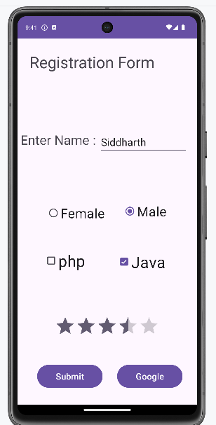 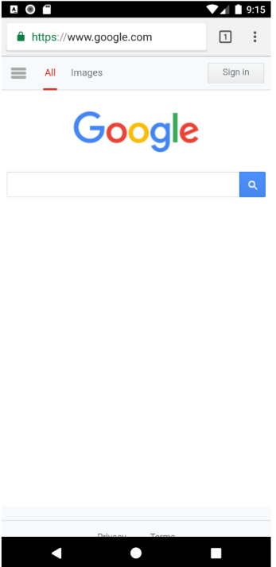

**Practical no: 5**

**Aim:- Create an Android application to demonstrate Toast.**

Code:-

**Activity_main.xml**

*<?*xml version="1.0" encoding="utf-8"*?>*<androidx.constraintlayout.widget.ConstraintLayout  
 xmlns:android="http://schemas.android.com/apk/res/android"  
 xmlns:app="http://schemas.android.com/apk/res-auto"  
 xmlns:tools="http://schemas.android.com/tools"  
 android:layout_width="match_parent"  
 android:layout_height="match_parent"  
 tools:context=".MainActivity">  
  
 <Button  
 android:id="@+id/Div"  
 android:layout_width="wrap_content"  
 android:layout_height="wrap_content"  
 android:text="Toast"  
 android:onClick="Toaster"  
 app:layout_constraintTop_toTopOf="parent"  
 app:layout_constraintBottom_toBottomOf="parent"  
 app:layout_constraintStart_toStartOf="parent"  
 app:layout_constraintEnd_toEndOf="parent"/>  
  
</androidx.constraintlayout.widget.ConstraintLayout>

**MainActivity.java**

package com.example.practical_5;  
  
import androidx.appcompat.app.AppCompatActivity;  
import android.os.Bundle;  
import android.view.View;  
import android.widget.Toast;  
  
public class MainActivity extends AppCompatActivity {  
  
 @Override  
 protected void onCreate(Bundle savedInstanceState) {  
 super.onCreate(savedInstanceState);  
 setContentView(R.layout.*activity_main*);  
 }  
  
 public void Toaster(View view) {  
 Toast.*makeText*(this, "Welcome to Application", Toast.*LENGTH_LONG*).show();  
 }  
}

Output:-

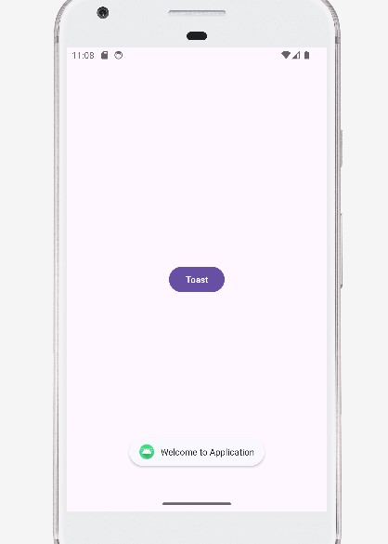

**Practical no: 6**

**Aim:- Create an Android Application to draw a filled circle using Canvas Class**

Code:-

**MainActivity.java**

package com.example.practical_6;  
  
import androidx.appcompat.app.AppCompatActivity;  
import android.graphics.Canvas;  
import android.graphics.Color;  
import android.graphics.Paint;  
import android.os.Bundle;  
import android.content.Context;  
import android.view.View;  
  
public class MainActivity extends AppCompatActivity {  
 @Override  
 protected void onCreate(Bundle savedInstanceState) {  
 super.onCreate(savedInstanceState);  
 setContentView(new Mview(this));  
 }  
  
 private class Mview extends View {  
 private Paint p;  
  
 public Mview(Context context) {  
 super(context);  
 p = new Paint();  
 }  
  
 @Override  
 protected void onDraw(Canvas canvas) {  
 super.onDraw(canvas);  
 int x = getWidth();  
 int y = getHeight();  
 int rad = 100;  
  
 *// Set background color to white* canvas.drawColor(Color.*WHITE*);  
  
 *// Draw a yellow circle at the center* p.setStyle(Paint.Style.*FILL*);  
 p.setColor(Color.*YELLOW*);  
 canvas.drawCircle(x / 2, y / 2, rad, p);  
  
 *// Draw a red rectangle* p.setColor(Color.*RED*); *// Optional: Set a different color for visibility* canvas.drawRect(300, 250, 480, 350, p);  
 }  
 }  
}

Output:-

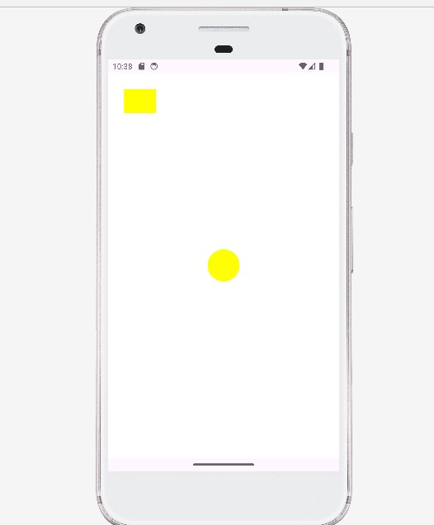

**Practical no: 7**

**Aim:- Create an Android application to demonstrate Alert window**

Code:-

**Activity_main.xml**

*<?*xml version="1.0" encoding="utf-8"*?>*<androidx.constraintlayout.widget.ConstraintLayout  
 xmlns:android="http://schemas.android.com/apk/res/android"  
 xmlns:app="http://schemas.android.com/apk/res-auto"  
 xmlns:tools="http://schemas.android.com/tools"  
 android:layout_width="match_parent"  
 android:layout_height="match_parent"  
 tools:context=".MainActivity">  
 <TextView  
 android:layout_width="wrap_content"  
 android:layout_height="wrap_content"  
 android:text="Hello World!"  
 app:layout_constraintBottom_toBottomOf="parent"  
 app:layout_constraintLeft_toLeftOf="parent"  
 app:layout_constraintRight_toRightOf="parent"  
 app:layout_constraintTop_toTopOf="parent" />  
 <Button  
 android:id="@+id/Button"  
 android:layout_width="wrap_content"  
 android:layout_height="wrap_content"  
 android:text="Button"  
 app:layout_constraintTop_toTopOf="parent"  
 app:layout_constraintBottom_toBottomOf="parent"  
 app:layout_constraintStart_toStartOf="parent"  
 app:layout_constraintEnd_toEndOf="parent"  
 app:layout_constraintVertical_bias="0.3" />  
</androidx.constraintlayout.widget.ConstraintLayout>

**MainActivity.java**

package com.example.practical_7;  
import androidx.appcompat.app.AlertDialog;  
import androidx.appcompat.app.AppCompatActivity;  
import android.os.Bundle;  
import android.content.DialogInterface;  
import android.widget.Button;  
import android.view.View;  
public class MainActivity extends AppCompatActivity {  
 @Override  
 protected void onCreate(Bundle savedInstanceState) {  
 super.onCreate(savedInstanceState);  
 setContentView(R.layout.*activity_main*);  
  
 *// Initialize the button and set up the click listener* setupButtonClickListener();  
 }  
 private void setupButtonClickListener() {  
 Button buttonSbm = findViewById(R.id.*Button*);  
 buttonSbm.setOnClickListener(new View.OnClickListener() {  
 @Override  
 public void onClick(View v) {  
 AlertDialog.Builder aBuilder = new AlertDialog.Builder(MainActivity.this);  
 aBuilder.setMessage("Do you want to close this app?")  
 .setCancelable(false)  
 .setPositiveButton("YES", new DialogInterface.OnClickListener() {  
 @Override  
 public void onClick(DialogInterface dialog, int which) {  
 finish(); *// Close the app* }})  
 .setNegativeButton("NO", new DialogInterface.OnClickListener() {  
 @Override  
 public void onClick(DialogInterface dialog, int which) {  
 dialog.dismiss(); *// Dismiss the dialog* }});  
 AlertDialog alert = aBuilder.create();  
 alert.setTitle("Alert!!");  
 alert.show();  
 }});  
 }  
}

Output:-

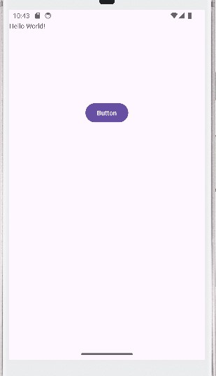 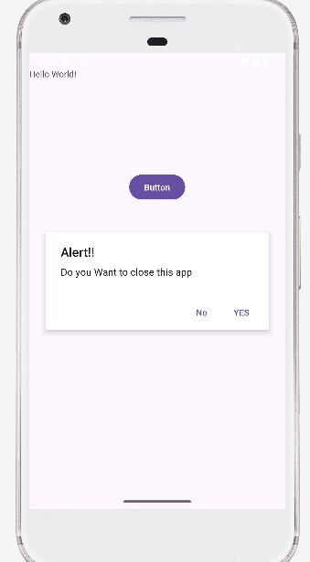

**Practical no: 8**

**Aim:- Create an Android Application to display image onclick of button**

Code:-

**Activity_main.xml**

<RelativeLayout xmlns:android="http://schemas.android.com/apk/res/android"  
 xmlns:app="http://schemas.android.com/apk/res-auto"  
 xmlns:tools="http://schemas.android.com/tools"  
 android:layout_width="match_parent"  
 android:layout_height="match_parent"  
 tools:context=".MainActivity">  
 *<!-- ImageView taking up most of the screen space above the Button -->* <ImageView  
 android:id="@+id/iv2"  
 android:layout_width="match_parent"  
 android:layout_height="wrap_content"  
 android:layout_alignParentStart="true"  
 android:layout_alignParentEnd="true"  
 android:layout_alignParentTop="true"  
 android:layout_alignParentBottom="@+id/bt1"  
 android:layout_marginBottom="19dp"  
 android:src="@drawable/ic_launcher_foreground"  
 android:scaleType="centerCrop" />  
 *<!-- Button centered at the bottom of the layout -->* <Button  
 android:id="@+id/bt1"  
 android:layout_width="wrap_content"  
 android:layout_height="wrap_content"  
 android:layout_alignParentStart="true"  
 android:layout_alignParentEnd="true"  
 android:layout_alignParentBottom="true"  
 android:layout_marginBottom="125dp"  
 android:text="Change" />  
 *<!-- ImageView above the Button -->* <ImageView  
 android:id="@+id/iv"  
 android:layout_width="wrap_content"  
 android:layout_height="wrap_content"  
 android:layout_above="@+id/bt1"  
 android:layout_alignParentStart="true"  
 android:layout_alignParentEnd="true"  
 android:layout_marginTop="16dp"  
 android:layout_marginBottom="16dp"  
 app:srcCompat="@drawable/pic" />  
</RelativeLayout>

**MainActivity.java**

package com.example.practical_7;  
  
import androidx.appcompat.app.AppCompatActivity;  
import android.os.Bundle;  
import android.view.View;  
import android.widget.Button;  
import android.widget.ImageView;  
public class MainActivity extends AppCompatActivity {  
 @Override  
 protected void onCreate(Bundle savedInstanceState) {  
 super.onCreate(savedInstanceState);  
 setContentView(R.layout.*activity_main*);  
 Button btn1 = findViewById(R.id.*bt1*);  
 ImageView iv = findViewById(R.id.*iv*);  
 btn1.setOnClickListener(new View.OnClickListener() {  
 @Override  
 public void onClick(View view) {  
 iv.setImageResource(R.drawable.*img*);  
 }  
 });  
 }  
}

Output:-

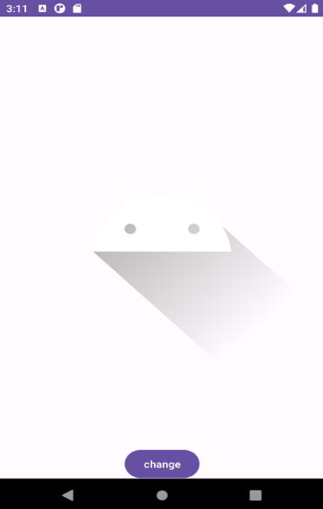 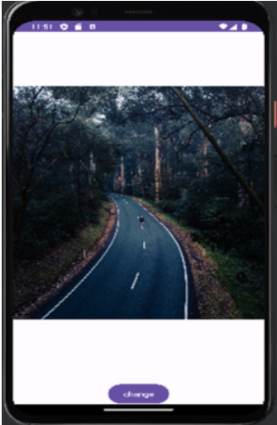

**Practical no: 9**

**Aim:- Create an Android application to display Menu (Option).**

Code:-

**Activity_main.xml**

*<?*xml version="1.0" encoding="utf-8"*?>*

<android.support.constraint.ConstraintLayoutxmlns:android="http://schemas.android.c om/apk/res/android"

xmlns:app="http://schemas.android.com/apk/res-auto"

xmlns:tools="http://schemas.android.com/tools"

android:layout_width="match_parent"

android:layout_height="match_parent"

tools:context="com.example.ashok.optionmenu.MainActivity">

</android.support.constraint.ConstraintLayout>

**menu.xml**

*<?*xml version="1.0" encoding="utf-8"*?>*

<menu xmlns:android="http://schemas.android.com/apk/res/android"> <item

android:id="@+id/a1"

android:title="Add"/>

<item

android:id="@+id/a2"

android:title="Edit"/>

<item

android:id="@+id/a3"

android:title="Delete"/>

<item

android:id="@+id/a4"

android:title="Save"/>

</menu>

**MainActivity.java**

package com.example.optionmenu;

import android.support.v7.app.AppCompatActivity;

import android.os.Bundle;

import android.view.Menu;

import android.view.MenuInflater;

import android.view.MenuItem;

import android.widget.Toast;

public class MainActivityextends AppCompatActivity {

@Override

protected void onCreate(Bundle savedInstanceState) {

super.onCreate(savedInstanceState);

setContentView(R.layout.*activity_main*);

 }

@Override

public booleanonCreateOptionsMenu(Menu menu) {

MenuInflater mi=getMenuInflater();

mi.inflate(R.menu.*menu*,menu);

return super.onCreateOptionsMenu(menu);

 }

@Override

public booleanonOptionsItemSelected(MenuItem item) {

switch(item.getItemId())

 {

case R.id.*a1*:

Toast.*makeText*(MainActivity.this,"add is selected",Toast.*LENGTH_SHORT*).show(); break;

case R.id.*a2*:

Toast.*makeText*(MainActivity.this,"edit is selected",Toast.*LENGTH_SHORT*).show(); break;

case R.id.*a3*:

Toast.*makeText*(MainActivity.this,"delete is selected",Toast.*LENGTH_SHORT*).show(); break;

case R.id.*a4*:

Toast.*makeText*(MainActivity.this,"save is selected",Toast.*LENGTH_SHORT*).show(); break;

default:

Toast.*makeText*(MainActivity.this,"please select

options",Toast.*LENGTH_SHORT*).show();

 }

return super.onOptionsItemSelected(item);

 }

}

Output:-

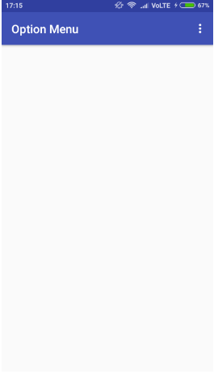 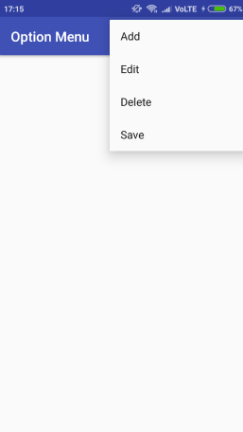

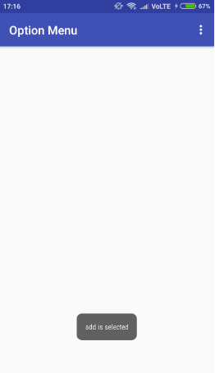

**Practical no: 10**

**Aim:- Create an Android application to display Video with forward, backward and pause options**

Code:-

**Activity_main.xml**

*<?***xml version="1.0" encoding="utf-8"***?>*

<**RelativeLayout xmlns:android="http://schemas.android.com/apk/res/android" xmlns:app="http://schemas.android.com/apk/res-auto"**

**xmlns:tools="http://schemas.android.com/tools"**

**android:layout_width="match_parent"**

**android:layout_height="match_parent"**

**tools:context=".MainActivity"**>

<**VideoView**

**android:id="@+id/videoView1"**

**android:layout_width="411dp"**

**android:layout_height="wrap_content"**

**android:layout_marginStart="8dp"**

**android:layout_marginLeft="8dp"**

**android:layout_marginTop="8dp"**

**android:layout_marginEnd="8dp"**

**android:layout_marginRight="8dp"**

**android:layout_marginBottom="8dp"**

**app:layout_constraintBottom_toBottomOf="parent"**

**app:layout_constraintEnd_toEndOf="parent"**

**app:layout_constraintStart_toStartOf="parent"**

**app:layout_constraintTop_toTopOf="parent"** />

</**RelativeLayout**>

**MainActivity.java**

**package** com.example.practical11;

**import** androidx.appcompat.app.AppCompatActivity;

**import** android.os.Bundle;

**import** android.widget.MediaController;

**import** android.widget.VideoView;

**public class** MainActivity **extends** AppCompatActivity {

 VideoView **videoid**;

 MediaController **mediaController**;

@Override

**protected void** onCreate(Bundle savedInstanceState) {

**super**.onCreate(savedInstanceState);

 setContentView(R.layout.***activity_main***);

**videoid** = (VideoView) findViewById(R.id.***videoView1***);

**mediaController** = **new** MediaController(**this**);

**videoid**.setVideoPath(**"android.resource://"** + getPackageName() + **"/"** +  R.raw.tom);

**mediaController**.setAnchorView(**videoid**);

**videoid**.setMediaController(**mediaController**);

**videoid**.start();

 }

}

Output:-

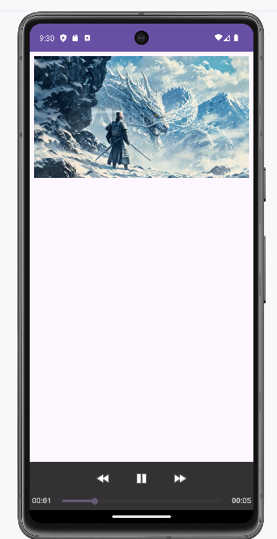

**Practical no: 11**

**Aim:- Create an Android Application to animate (Fade, Rotate, Move & Blink) an image.**

Code:-

**Activity_main.xml**

<RelativeLayout xmlns:android="http://schemas.android.com/apk/res/android"  
 xmlns:app="http://schemas.android.com/apk/res-auto"  
 xmlns:tools="http://schemas.android.com/tools"  
 android:layout_width="match_parent"  
 android:layout_height="match_parent"  
 tools:context=".MainActivity">  
  
 <ImageView  
 android:id="@+id/imageView"  
 android:layout_width="150dp"  
 android:layout_height="150dp"  
 android:layout_marginStart="8dp"  
 android:layout_marginLeft="8dp"  
 android:layout_marginTop="48dp"  
 android:layout_marginEnd="8dp"  
 android:layout_marginRight="8dp"  
 android:layout_marginBottom="8dp"  
 app:srcCompat="@drawable/pic" />  
  
 <Button  
 android:id="@+id/button"  
 android:layout_width="wrap_content"  
 android:layout_height="wrap_content"  
 android:layout_below="@id/button3"  
 android:layout_marginStart="8dp"  
 android:layout_marginLeft="8dp"  
 android:layout_marginEnd="8dp"  
 android:layout_marginRight="8dp"  
 android:onClick="move"  
 android:text="Move" />  
  
 <Button  
 android:id="@+id/button2"  
 android:layout_width="wrap_content"  
 android:layout_height="wrap_content"  
 android:layout_below="@id/imageView"  
 android:layout_centerHorizontal="true"  
 android:layout_marginStart="8dp"  
 android:layout_marginLeft="8dp"  
 android:layout_marginTop="8dp"  
 android:layout_marginEnd="8dp"  
 android:layout_marginRight="8dp"  
 android:layout_marginBottom="8dp"  
 android:onClick="fade"  
 android:text="Fade" />  
  
 <Button  
 android:id="@+id/button3"  
 android:layout_width="wrap_content"  
 android:layout_height="wrap_content"  
 android:layout_below="@id/imageView"  
 android:layout_marginLeft="8dp"  
 android:layout_marginTop="8dp"  
 android:layout_marginRight="8dp"  
 android:layout_marginBottom="8dp"  
 android:onClick="rotate"  
 android:text="Rotate" />  
  
 <Button  
 android:id="@+id/button4"  
 android:layout_width="wrap_content"  
 android:layout_height="wrap_content"  
 android:layout_below="@id/button2"  
 android:layout_centerHorizontal="true"  
 android:layout_marginBottom="8dp"  
 android:onClick="blink"  
 android:text="Blink" />  
</RelativeLayout>

**MainActivity.java**

package com.example.practical_11;  
import androidx.appcompat.app.AppCompatActivity;  
import android.os.Bundle;  
import android.view.View;  
import android.view.animation.Animation;  
import android.view.animation.AnimationUtils;  
import android.widget.ImageView;  
public class MainActivity extends AppCompatActivity{ @Override  
protected void onCreate(Bundle savedInstanceState)  
{  
 super.onCreate(savedInstanceState); setContentView(R.layout.activity_main);  
}  
 public void move(View view) {  
 ImageView image= findViewById(R.id.imageView); Animation animate1=  
 AnimationUtils.*loadAnimation*(getApplicationContext(),R.anim.move); image.startAnimation(animate1);  
 }  
 public void fade(View view)  
 {  
 ImageView image= findViewById(R.id.imageView);  
 Animation animate2=AnimationUtils.*loadAnimation*(getApplicationContext(),R.anim.fade_in);  
 image.startAnimation(animate2);  
 }  
  
 public void rotate(View view)  
 {  
 ImageView image= findViewById(R.id.imageView);  
 Animation animate3=AnimationUtils.*loadAnimation*(getApplicationContext(),R.anim.rotate);  
 image.startAnimation(animate3);  
 }  
 public void blink(View view)  
 {  
 ImageView image= findViewById(R.id.imageView);  
 Animation animate4=AnimationUtils.*loadAnimation*(getApplicationContext(),R.anim.blink);  
 image.startAnimation(animate4);  
 }  
}  
Move.xml  
<?xml version="1.0" encoding="utf-8"?>  
<set  
xmlns:android="http://schemas.android.com/apk/res/android"  
android:interpolator="@android:anim/linear_interpolator"  
android:fillAfter="true">  
<translate  
android:fromXDelta="0%p"  
android:toXDelta="75%p"  
android:duration="800" />  
</set>

**Blink.xml**

*<?*xml version="1.0" encoding="utf-8"*?>*<set xmlns:android="http://schemas.android.com/apk/res/android">  
 <alpha android:fromAlpha="0.0" android:toAlpha="1.0"  
 android:interpolator="@android:anim/accelerate_interpolator" android:duration="600"  
 android:repeatMode="reverse" android:repeatCount="infinite"/>  
</set>

**Rotate.xml**

*<?*xml version="1.0" encoding="utf-8"*?>*<set xmlns:android="http://schemas.android.com/apk/res/android">  
 <rotate android:fromDegrees="0" android:toDegrees="360" android:pivotX="50%" android:pivotY="50%" android:duration="600" android:repeatMode="restart" android:repeatCount="infinite"  
 android:interpolator="@android:anim/cycle_interpolator"/>  
</set>

**Fade.xml**

*<?*xml version="1.0" encoding="utf-8"*?>*<set xmlns:android="http://schemas.android.com/apk/res/android" android:fillAfter="true" >  
 <alpha  
 android:duration="1000" android:fromAlpha="0.0"  
 android:interpolator="@android:anim/accelerate_interpolator" android:toAlpha="1.0" />  
</set>

Output:-

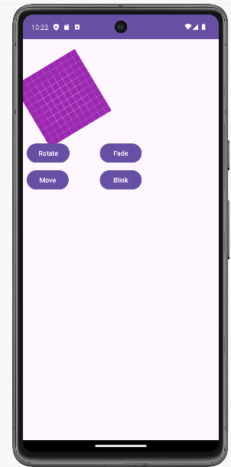 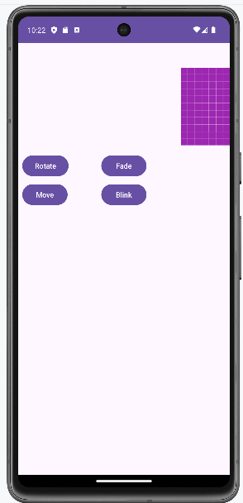

**Practical no: 12**

**Aim: Create an Android application to Insert, Delete, Update and View the SQLite Database**

**Code:-**

**activity_main.xml**

*<?***xml version="1.0" encoding="utf-8"***?>*

<**RelativeLayout xmlns:android="http://schemas.android.com/apk/res/android" xmlns:app="http://schemas.android.com/apk/res-auto"**

**xmlns:tools="http://schemas.android.com/tools"**

**android:layout_width="match_parent"**

**android:layout_height="match_parent"**

**tools:context=".MainActivity"**>

<**Button**

**android:id="@+id/btnselect"**

**android:layout_width="wrap_content"**

**android:layout_height="wrap_content"**

**android:layout_alignParentStart="true"**

**android:layout_alignParentLeft="true"**

**android:layout_alignParentBottom="true"**

**android:layout_marginStart="50dp"**

**android:layout_marginLeft="50dp"**

**android:layout_marginBottom="201dp"**

**android:text="View"** />

<**Button**

**android:id="@+id/btnsave"**

**android:layout_width="wrap_content"**

**android:layout_height="wrap_content"**

**android:layout_alignBottom="@+id/btnselect"**

**android:layout_alignParentEnd="true"**

**android:layout_alignParentRight="true"**

**android:layout_marginEnd="69dp"**

**android:layout_marginRight="69dp"**

**android:layout_marginBottom="0dp"**

**android:text="Save"** />

<**Button**

**android:id="@+id/btnupdate"**

**android:layout_width="wrap_content"**

**android:layout_height="wrap_content"**

**android:layout_alignStart="@+id/btnselect"**

**android:layout_alignLeft="@id/btnselect"**

**android:layout_alignParentBottom="true"**

**android:layout_marginStart="-7dp"**

**android:layout_marginLeft="-7dp"**

**android:layout_marginBottom="72dp"**

**android:text="Update"** />

<**Button**

**android:id="@+id/btnselectparticular"**

**android:layout_width="107dp"**

**android:layout_height="33dp"**

**android:layout_below="@+id/editTextMessage"**

**android:layout_alignParentStart="true"**

**android:layout_alignParentLeft="true"**

**android:layout_alignParentEnd="true" android:layout_alignParentRight="true" android:layout_alignParentBottom="true" android:layout_marginStart="141dp" android:layout_marginLeft="141dp" android:layout_marginTop="330dp" android:layout_marginEnd="163dp" android:layout_marginRight="163dp" android:layout_marginBottom="127dp" android:text="Search"** />

<**Button**

**android:id="@+id/btndel"**

**android:layout_width="102dp"**

**android:layout_height="wrap_content" android:layout_below="@+id/btnsave" android:layout_alignParentStart="true" android:layout_alignParentLeft="true" android:layout_alignParentEnd="true" android:layout_alignParentRight="true" android:layout_alignParentBottom="true" android:layout_marginStart="240dp" android:layout_marginLeft="240dp" android:layout_marginTop="79dp" android:layout_marginEnd="42dp" android:layout_marginRight="42dp" android:layout_marginBottom="74dp" android:text="Delete"** />

<**EditText**

**android:id="@+id/editTextSearch" android:layout_width="wrap_content" android:layout_height="wrap_content" android:layout_alignParentStart="true" android:layout_alignParentLeft="true" android:layout_alignParentTop="true" android:layout_marginStart="68dp" android:layout_marginLeft="68dp" android:layout_marginTop="54dp" android:ems="10"**

**android:hint="Search"**

**android:inputType="textPersonName" android:text=""** />

<**EditText**

**android:id="@+id/editTextEmailAddress" android:layout_width="wrap_content" android:layout_height="wrap_content" android:layout_alignParentStart="true" android:layout_alignParentLeft="true" android:layout_alignParentTop="true" android:layout_marginStart="67dp" android:layout_marginLeft="67dp" android:layout_marginTop="145dp" android:ems="10"**

**android:hint="Enter Your EmailAddress" android:inputType="textPersonName" android:text=""** />

<**EditText**

**android:id="@+id/editTextMessage" android:layout_width="wrap_content" android:layout_height="wrap_content" android:layout_alignParentStart="true" android:layout_alignParentLeft="true"**

**android:layout_alignParentTop="true"**

**android:layout_marginStart="67dp"**

**android:layout_marginLeft="67dp"**

**android:layout_marginTop="196dp"**

**android:ems="10"**

**android:hint="Enter Your Message"**

**android:inputType="textPersonName"**

**android:text=""** />

<**EditText**

**android:id="@+id/editTextName"**

**android:layout_width="wrap_content"**

**android:layout_height="wrap_content"**

**android:layout_alignParentStart="true"**

**android:layout_alignParentLeft="true"**

**android:layout_alignParentTop="true"**

**android:layout_marginStart="69dp"**

**android:layout_marginLeft="69dp"**

**android:layout_marginTop="99dp"**

**android:ems="10"**

**android:hint="Enter Your Name"**

**android:inputType="textPersonName"**

**android:text=""** />

<**TextView**

**android:id="@+id/textView5"**

**android:layout_width="wrap_content"**

**android:layout_height="wrap_content"**

**android:layout_alignParentStart="true"**

**android:layout_alignParentLeft="true"**

**android:layout_alignParentTop="true"**

**android:layout_marginStart="122dp"**

**android:layout_marginLeft="122dp"**

**android:layout_marginTop="24dp"**

**android:text="Contact Us"**

**android:textSize="18sp"**

**android:textStyle="bold"**

**app:fontFamily="serif"** />

</**RelativeLayout**>

**MainActivity.java**

**package** com.example.practical_13;

**import** androidx.appcompat.app.AppCompatActivity;

**import** android.content.Context;

**import** android.database.Cursor;

**import** android.database.sqlite.SQLiteDatabase;

**import** android.os.Bundle;

**import** android.view.View;

**import** android.widget.Button;

**import** android.widget.EditText;

**import** android.widget.Toast;

**public class** MainActivity **extends** AppCompatActivity **implements** View.OnClickListener {

 SQLiteDatabase **db**;

 EditText **editSearchContact**, **editName**, **editEmailAddress**, **editMessage**;  Button **Add**, **Delete**, **Modify**, **View**, **search**;

@Override

**protected void** onCreate(Bundle savedInstanceState) {

**super**.onCreate(savedInstanceState);

 setContentView(R.layout.***activity_main***);

**db** = openOrCreateDatabase(**"ContactDb"**, Context.***MODE_PRIVATE***, **null**); **db**.execSQL(**"CREATE TABLE IF NOT EXISTS Contact_49(cId INTEGER PRIMARY KEY  AUTOINCREMENT, Name VARCHAR, Mail VARCHAR, CMessage VARCHAR); "**); **editSearchContact** = (EditText) findViewById(R.id.***editTextSearch***); **editName** = (EditText) findViewById(R.id.***editTextName***);

**editEmailAddress** = (EditText) findViewById(R.id.***editTextEmailAddress***); **editMessage** = (EditText) findViewById(R.id.***editTextMessage***); **Add** = (Button) findViewById(R.id.***btnsave***);

**Delete** = (Button) findViewById(R.id.***btndel***);

**Modify** = (Button) findViewById(R.id.***btnupdate***);

**View** = (Button) findViewById(R.id.***btnselect***);

**search** = (Button) findViewById(R.id.***btnselectparticular***); **Add**.setOnClickListener(**this**);

**Delete**.setOnClickListener(**this**);

**Modify**.setOnClickListener(**this**);

**View**.setOnClickListener(**this**);

**search**.setOnClickListener(**this**);

 }

**public void** msg(Context context, String str) {

 Toast.*makeText*(**this**, str, Toast.***LENGTH_SHORT***).show();  }

**public void** onClick(android.view.View v) {

**if** (v.getId() == R.id.***btnsave***) {

*// code for save data*

**if** (**editName**.getText().toString().trim().length() == 0 ||  **editEmailAddress**.getText().toString().trim().length() == 0 ||  **editMessage**.getText().toString().trim().length() == 0)

 {

 msg(**this**, **"Please enter all values"**);

**return**;

 }

**db**.execSQL(**"INSERT INTO Contact_49(Name,Mail,CMessage)VALUES('"** + **editName**.getText() + **"','"** + **editEmailAddress**.getText() + **"','"** +  **editMessage**.getText() + **"');"**);

**editName**.getText().clear();

**editEmailAddress**.getText().clear();

**editMessage**.getText().clear();

 msg(**this**, **"Response Noted, Thanks!!"**);

 }

**else if** (v.getId() == R.id.***btnupdate***)

 {

*//code for update data*

**if** (**editSearchContact**.getText().toString().trim().length() == 0) {  msg(**this**, **"Enter Name"**);

**return**;

 }

 Cursor c = **db**.rawQuery(**"SELECT * FROM Contact_49 WHERE Name='"** +

**editSearchContact**.getText() + **"'"**, **null**);

**if** (c.moveToFirst()) {

**db**.execSQL(**"UPDATE Contact_49 SET Name ='"** + **editName**.getText() + **"', Mail  = '"** + **editEmailAddress**.getText() + **"', CMessage = '"** +

**editMessage**.getText() + **"' WHERE Name = '"** + **editSearchContact**.getText() +  **"'"**);

**editName**.getText().clear();

**editEmailAddress**.getText().clear();

**editMessage**.getText().clear();

**editSearchContact**.getText().clear();

 msg(**this**, **"Record Modified"**);

 } **else** {

 msg(**this**, **"Invalid Name"**);

 }

 }

**else if** (v.getId() == R.id.***btndel***) {

*//code for delete data*

**if** (**editSearchContact**.getText().toString().trim().length() == 0) {  msg(**this**, **" Please enter Name "**);

**return**;

 }

 Cursor c = **db**.rawQuery(**"SELECT * FROM Contact_49 WHERE Name ='"**+

**editSearchContact**.getText() + **"'"**, **null**);

**if** (c.moveToFirst()) {

**db**.execSQL(**"DELETE FROM Contact_49 WHERE Name ='"** +

**editSearchContact**.getText() + **"'"**);

**editName**.getText().clear();

**editEmailAddress**.getText().clear();

**editMessage**.getText().clear();

 msg(**this**, **"Record Deleted"**);

 } **else** {

 msg(**this**, **"Invalid Name "**);

 }

 }

**else if** (v.getId() == R.id.***btnselect***) {

*//code for select all data*

Cursor c = **db**.rawQuery(**"SELECT * FROM Contact_49"**, **null**);

**if** (c.getCount() == 0) {

 msg(**this**, **"No records found"**);

**return**;

 }

 StringBuffer buffer = **new** StringBuffer();

**while** (c.moveToNext()) {

 buffer.append(**"Name: "** + c.getString(1) + **"\n"**);  buffer.append(**"Mail: "** + c.getString(2) + **"\n\n"**);  buffer.append(**"Message: "** + c.getString(3) + **"\n\n"**);  }

 msg(**this**, buffer.toString());

 } **else if** (v.getId() == R.id.***btnselectparticular***) { *//code for select particular data*

**if** (**editSearchContact**.getText().toString().trim().length() == 0) {  msg(**this**, **"Enter Name"**);

**return**;

 }

 Cursor c = **db**.rawQuery(**"SELECT * FROM Contact_49 WHERE Name='"** +

**editSearchContact**.getText() + **"'"**, **null**);

**if** (c.moveToFirst()) {

**editName**.setText(c.getString(1));

**editEmailAddress**.setText(c.getString(2));

**editMessage**.setText(c.getString(3));

 } **else** {

 msg(**this**, **"Invalid Name"**);

 }

 }

 }

}

Output:-

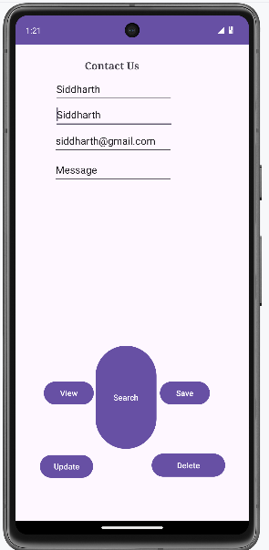 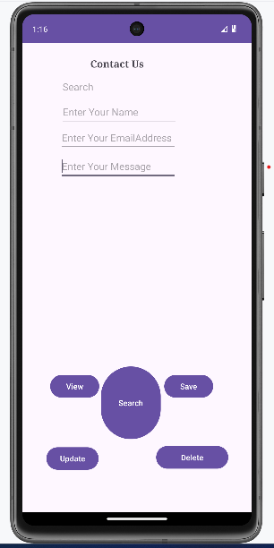

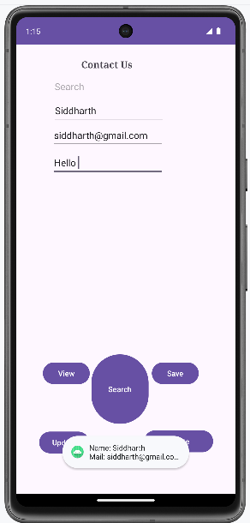

**Practical no: 13**

**Aim:- Create an Android Application to show the data of one page to the other using shared preference**

Code:-

**Activity_main.xml**

<androidx.constraintlayout.widget.ConstraintLayout xmlns:android="http://schemas.android.com/apk/res/android"  
 xmlns:app="http://schemas.android.com/apk/res-auto"  
 xmlns:tools="http://schemas.android.com/tools"  
 android:layout_width="match_parent"  
 android:layout_height="match_parent"  
 tools:context=".MainActivity">  
  
 <TextView  
 android:id="@+id/textView_emailId"  
 android:layout_width="wrap_content"  
 android:layout_height="wrap_content"  
 android:text="Email Id :"  
 android:textSize="24sp"  
 app:layout_constraintBottom_toBottomOf="parent"  
 app:layout_constraintEnd_toEndOf="parent"  
 app:layout_constraintHorizontal_bias="0.095"  
 app:layout_constraintStart_toStartOf="parent"  
 app:layout_constraintTop_toTopOf="parent"  
 app:layout_constraintVertical_bias="0.22" />  
  
 <TextView  
 android:id="@+id/textView_password"  
 android:layout_width="wrap_content"  
 android:layout_height="wrap_content"  
 android:text="Password :"  
 android:textSize="24sp"  
 app:layout_constraintBottom_toBottomOf="parent"  
 app:layout_constraintEnd_toEndOf="parent"  
 app:layout_constraintHorizontal_bias="0.03"  
 app:layout_constraintStart_toStartOf="parent"  
 app:layout_constraintTop_toTopOf="parent"  
 app:layout_constraintVertical_bias="0.351" />  
  
 <EditText  
 android:id="@+id/editText_email"  
 android:layout_width="202dp"  
 android:layout_height="54dp"  
 android:ems="10"  
 android:inputType="textPersonName"  
 android:textSize="24sp"  
  
 app:layout_constraintBottom_toBottomOf="parent"  
 app:layout_constraintEnd_toEndOf="parent"  
 app:layout_constraintHorizontal_bias="0.802"  
 app:layout_constraintStart_toStartOf="parent"  
 app:layout_constraintTop_toTopOf="parent"  
 app:layout_constraintVertical_bias="0.227" />  
  
 <EditText  
 android:id="@+id/editText_password"  
 android:layout_width="191dp"  
 android:layout_height="43dp"  
 android:ems="10"  
 android:inputType="textPersonName"  
 android:textSize="24sp"  
 app:layout_constraintBottom_toBottomOf="parent"  
 app:layout_constraintEnd_toEndOf="parent"  
 app:layout_constraintHorizontal_bias="0.799"  
 app:layout_constraintStart_toStartOf="parent"  
 app:layout_constraintTop_toTopOf="parent"  
 app:layout_constraintVertical_bias="0.372" />  
  
 <CheckBox  
 android:id="@+id/checkBox"  
 android:layout_width="wrap_content"  
 android:layout_height="wrap_content"  
 android:text="Remember Me"  
 android:textSize="18sp"  
 app:layout_constraintBottom_toBottomOf="parent"  
 app:layout_constraintEnd_toEndOf="parent"  
 app:layout_constraintStart_toStartOf="parent"  
 app:layout_constraintTop_toTopOf="parent" />  
  
 <Button  
 android:id="@+id/button_signIn"  
 android:layout_width="wrap_content"  
 android:layout_height="wrap_content"  
 android:onClick="Save"  
 android:text="Sign In"  
 android:textSize="18sp"  
 app:layout_constraintBottom_toBottomOf="parent"  
 app:layout_constraintEnd_toEndOf="parent"  
 app:layout_constraintHorizontal_bias="0.216"  
 app:layout_constraintStart_toStartOf="parent"  
 app:layout_constraintTop_toTopOf="parent"  
 app:layout_constraintVertical_bias="0.639" />  
  
 <Button  
 android:id="@+id/button_clear"  
 android:layout_width="wrap_content"  
 android:layout_height="wrap_content"  
 android:onClick="clear"  
 android:text="Clear"  
 android:textSize="18sp"  
 app:layout_constraintBottom_toBottomOf="parent"  
 app:layout_constraintEnd_toEndOf="parent"  
 app:layout_constraintHorizontal_bias="0.526"  
  
 app:layout_constraintStart_toStartOf="parent"  
 app:layout_constraintTop_toTopOf="parent"  
 app:layout_constraintVertical_bias="0.758" />  
  
 <Button  
 android:id="@+id/button_getData"  
 android:layout_width="wrap_content"  
 android:layout_height="wrap_content"  
 android:onClick="Get"  
 android:text="Get Data"  
 android:textSize="18sp"  
 app:layout_constraintBottom_toBottomOf="parent"  
 app:layout_constraintEnd_toEndOf="parent"  
 app:layout_constraintHorizontal_bias="0.848"  
 app:layout_constraintStart_toStartOf="parent"  
 app:layout_constraintTop_toTopOf="parent"  
 app:layout_constraintVertical_bias="0.639" />  
</androidx.constraintlayout.widget.ConstraintLayout>

**MainActivity.java**

package com.example.practical_13;  
import androidx.appcompat.app.AppCompatActivity;  
import android.content.Context;  
import android.content.SharedPreferences;  
import android.os.Bundle;  
import android.view.View;  
import android.widget.CheckBox;  
import android.widget.TextView;  
import android.widget.Toast;  
  
public class MainActivity extends AppCompatActivity {  
 SharedPreferences sharedPreferences;  
 TextView password;  
 TextView email;  
 CheckBox remember;  
  
 public static final String *mypreferences* = "mypref";  
 public static final String *Email* = "emailKey";  
 public static final String *Password* = "passwordKey";  
  
 @Override  
 protected void onCreate(Bundle savedInstanceState) {  
 super.onCreate(savedInstanceState);  
 setContentView(R.layout.*activity_main*);  
  
 email = findViewById(R.id.editText_email);  
 password = findViewById(R.id.editText_password);  
 remember = findViewById(R.id.checkBox);  
  
 sharedPreferences = getSharedPreferences(*mypreferences*, Context.*MODE_PRIVATE*);  
  
 *// Load saved data if available* if (sharedPreferences.contains(*Email*)) {  
 email.setText(sharedPreferences.getString(*Email*, ""));  
 }  
  
 if (sharedPreferences.contains(*Password*)) {  
 password.setText(sharedPreferences.getString(*Password*, ""));  
 }  
 }public void Get(View view) {  
 if (sharedPreferences.contains(*Email*)) {  
 email.setText(sharedPreferences.getString(*Email*, ""));  
 }  
 if (sharedPreferences.contains(*Password*)) {  
 password.setText(sharedPreferences.getString(*Password*, ""));  
 }  
 }  
public void Save(View view) {  
 if (remember.isChecked()) {  
 String e = email.getText().toString();  
 String p = password.getText().toString();  
  
 SharedPreferences.Editor editor = sharedPreferences.edit();  
 editor.putString(*Email*, e);  
 editor.putString(*Password*, p);  
 editor.apply(); *// Asynchronously save data* Toast.*makeText*(getApplicationContext(), "Values stored in shared preferences", Toast.*LENGTH_SHORT*).show();  
 }  
 }public void clear(View view) {  
 email.setText("");  
 password.setText("");  
 }  
}

Output:-

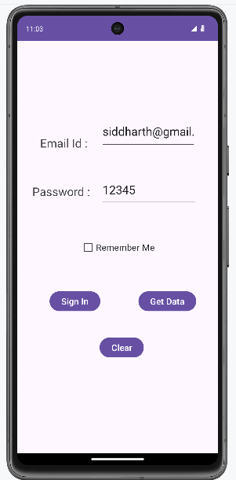 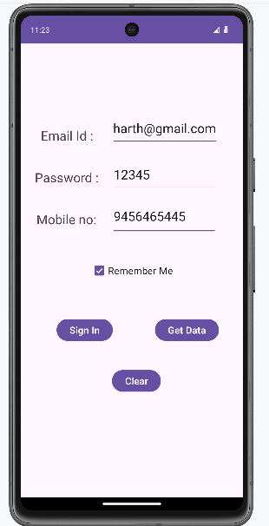

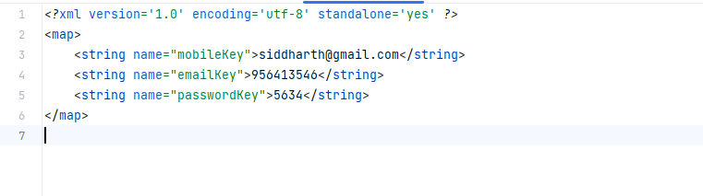

**Practical no: 14**

**Aim:- Create an Android Application to Create, Read and Delete file (Internal).**

Code:-

**Activity_main.xml**

*<?*xml version="1.0" encoding="utf-8"*?>*<RelativeLayout xmlns:android="http://schemas.android.com/apk/res/android"  
 xmlns:app="http://schemas.android.com/apk/res-auto"  
 xmlns:tools="http://schemas.android.com/tools"  
 android:layout_width="match_parent"  
 android:layout_height="match_parent"  
 tools:context=".MainActivity">  
  
 <EditText  
 android:id="@+id/txtcontent"  
 android:layout_width="match_parent"  
 android:layout_height="wrap_content"  
 android:layout_marginStart="17dp"  
 android:layout_marginTop="16dp"  
 android:layout_marginEnd="15dp"  
 android:inputType="textPersonName"  
 tools:ignore="TouchTargetSizeCheck,SpeakableTextPresentCheck" />  
  
 <Button  
 android:id="@+id/btnwrite"  
 android:layout_width="wrap_content"  
 android:layout_height="wrap_content"  
 android:layout_below="@+id/txtcontent"  
 android:layout_alignParentEnd="true"  
 android:layout_marginTop="16dp"  
 android:layout_marginEnd="13dp"  
 android:text="Write" />  
 <Button  
 android:id="@+id/btnread"  
 android:layout_width="wrap_content"  
 android:layout_height="wrap_content"  
 android:layout_alignParentStart="true"  
 android:layout_alignParentTop="true"  
 android:layout_marginStart="16dp"  
 android:layout_marginTop="16dp"  
 android:text="Read" />  
 <TextView  
 android:id="@+id/textView"  
 android:layout_width="wrap_content"  
 android:layout_height="wrap_content"  
 android:layout_alignParentStart="true"  
 android:layout_alignParentBottom="true"  
 android:layout_marginStart="16dp"  
 android:layout_marginBottom="16dp"  
 android:text="TextView" />  
 <Button  
 android:id="@+id/btn_clear"  
 android:layout_width="wrap_content"  
 android:layout_height="wrap_content"  
 android:layout_below="@+id/btnwrite"  
 android:layout_marginStart="16dp"  
 android:layout_marginTop="16dp"  
 android:onClick="clearFile"  
 android:text="Clear" />  
 <Button  
 android:id="@+id/btn_delete"  
 android:layout_width="wrap_content"  
 android:layout_height="wrap_content"  
 android:layout_below="@+id/btn_clear"  
 android:layout_alignParentEnd="true"  
 android:layout_marginTop="16dp"  
 android:layout_marginEnd="16dp"  
 android:onClick="deleteFile"  
 android:text="Delete" />  
</RelativeLayout>

**MainActivity.java**

package com.example.practical_10;  
  
import androidx.appcompat.app.AppCompatActivity;  
import android.os.Bundle;  
import android.content.Context;  
import android.view.View;  
import android.widget.EditText;  
import android.widget.TextView;  
import android.widget.Button;  
import android.widget.Toast;  
import java.io.File;  
import java.io.FileInputStream;  
import java.io.FileOutputStream;  
public class MainActivity extends AppCompatActivity {  
 EditText et_Text;  
 Button b_read, b_write, b_delete;  
 TextView tv_Text;  
 String file_name = "file.txt";  
 @Override  
 protected void onCreate(Bundle savedInstanceState) {  
 super.onCreate(savedInstanceState);  
 setContentView(R.layout.*activity_main*);  
*// Initialize views* et_Text = findViewById(R.id.*txtcontent*);  
 b_read = findViewById(R.id.*btnread*);  
 b_write = findViewById(R.id.*btnwrite*);  
 tv_Text = findViewById(R.id.*textView*);  
 b_delete = findViewById(R.id.*btn_delete*);  
*// Set initial text from the file* tv_Text.setText(readFile(file_name));  
*// Set up button click listeners* b_read.setOnClickListener(new View.OnClickListener() {  
 @Override  
 public void onClick(View view) {  
 tv_Text.setText(readFile(file_name));  
 Toast.*makeText*(MainActivity.this, "File read", Toast.*LENGTH_SHORT*).show();  
 }  
 });  
  
 b_write.setOnClickListener(new View.OnClickListener() {  
 @Override  
 public void onClick(View view) {  
 saveFile(file_name, et_Text.getText().toString());  
 Toast.*makeText*(MainActivity.this, "Text saved", Toast.*LENGTH_SHORT*).show();  
 }  
 });  
  
 b_delete.setOnClickListener(new View.OnClickListener() {  
 @Override  
 public void onClick(View view) {  
 deleteFile();  
 }  
 });  
 }  
  
 private void saveFile(String file_name, String text) {  
 try {  
 FileOutputStream fos = openFileOutput(file_name, Context.*MODE_PRIVATE*);  
 fos.write(text.getBytes());  
 fos.close();  
 } catch (Exception e) {  
 e.printStackTrace();  
 Toast.*makeText*(MainActivity.this, "Error saving file", Toast.*LENGTH_SHORT*).show();  
 }  
 }  
  
 private String readFile(String file_name) {  
 String text = "";  
 try {  
 FileInputStream fis = openFileInput(file_name);  
 int size = fis.available();  
 byte[] buffer = new byte[size];  
 fis.read(buffer);  
 fis.close();  
 text = new String(buffer);  
 } catch (Exception e) {  
 e.printStackTrace();  
 Toast.*makeText*(MainActivity.this, "Error reading file", Toast.*LENGTH_SHORT*).show();  
 }  
 return text;  
 }  
  
 public void clearFile(View view) {  
 et_Text.getText().clear();  
 }  
  
 private void deleteFile() {  
 File file = new File(getFilesDir(), file_name);  
 if (file.exists()) {  
 if (file.delete()) {  
 Toast.*makeText*(MainActivity.this, "File deleted", Toast.*LENGTH_SHORT*).show();  
 } else {  
 Toast.*makeText*(MainActivity.this, "Error deleting file", Toast.*LENGTH_SHORT*).show();  
 }  
 } else {  
 Toast.*makeText*(MainActivity.this, "File not found", Toast.*LENGTH_SHORT*).show();  
 }  
 }  
}

Output:-

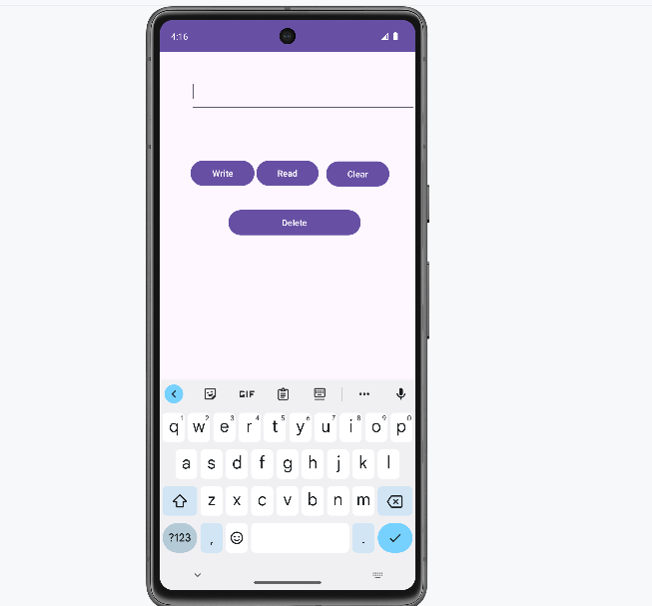 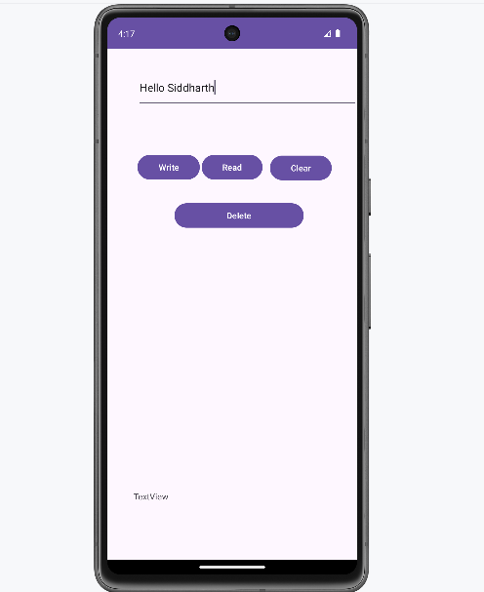

**Practical no: 15**

**Aim:- Create an Android Application to Start and Stop Alarm using Services**

Code :-

**Activity_main.xml**

*<?***xml version="1.0" encoding="utf-8"***?>*

<**LinearLayout**

**xmlns:android="http://schemas.android.com/apk/res/android" xmlns:app="http://schemas.android.com/apk/res-auto" xmlns:tools="http://schemas.android.com/tools"**

**android:layout_width="match_parent"**

**android:layout_height="match_parent"**

**android:orientation="vertical"**

**tools:context=".MainActivity"**>

<**TextView**

**android:layout_width="wrap_content"**

**android:layout_height="wrap_content"**

**android:text="Start Stop"**

**app:layout_constraintBottom_toBottomOf="parent"**

**app:layout_constraintLeft_toLeftOf="parent"**

**app:layout_constraintRight_toRightOf="parent"**

**app:layout_constraintTop_toTopOf="parent"** />

<**Button**

**android:layout_width="wrap_content"**

**android:layout_height="wrap_content"**

**android:onClick="onClick"**

**android:id="@+id/start"**

**android:text="Start"**/>

<**Button**

**android:layout_width="wrap_content"**

**android:layout_height="wrap_content"**

**android:onClick="onClick"**

**android:text="Stop"**

**android:id="@+id/stop"**/>

</**LinearLayout**>

**MainActivity.java**

**package** com.example.practical18;

**import** androidx.appcompat.app.AppCompatActivity ; **import** android.content.Intent;

**import** android.media.MediaPlayer;

**import** android.os.Bundle;

**import** android.provider.Settings;

**import** android.sax.StartElementListener;

**import** android.view.View;

**import** android.widget.Button;

**public class** MainActivity **extends** AppCompatActivity **implements**View.OnClickListener{

**private** Button **b1**,**b2**;

@Override

**protected void** onCreate(Bundle savedInstanceState) { **super**.onCreate(savedInstanceState);

 setContentView(R.layout.***activity_main***);

**b1**=(Button)findViewById(R.id.***start***);

**b2**=(Button)findViewById(R.id.***stop***);

**b1**.setOnClickListener(**this**);

**b2**.setOnClickListener(**this**);

 }

**public void** onClick(View view) {

**if**(view==**b1**)

 {

 startService(**new** Intent(**this**,MyService.**class**));  }

**else**

{

 stopService(**new** Intent(**this**,MyService.**class**));  }

 }

}

**MyService.java**

**package** com.example.practical18;

**import** android.app.Service;

**import** android.content.Intent;

**import** android.media.MediaPlayer;

**import** android.os.IBinder;

**import** android.provider.Settings;

**import** androidx.annotation.Nullable;

**public class** MyService **extends** Service {

**public** MyService() {

**super**();

 }

 MediaPlayer **m**;

@Override

**public int** onStartCommand(Intent intent, **int** flags, **int** startId) { **m**=MediaPlayer.*create*(**this**, Settings.System.***DEFAULT_RINGTONE_URI***); **m**.setLooping(**true**);

**m**.start();

**return *START_STICKY***;

 }

@Override

**public void** onDestroy() {

**super**.onDestroy();

**m**.stop();

 }

@Nullable

 @Override

**public** IBinder onBind(Intent intent) {

**return null**;

 }

}

Output:-

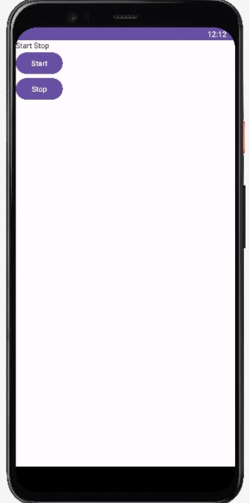

**Practical no: 16**

**Aim:- Write a application to display latitude and longitude of current Location**

Code:-

**Activity_main.xml**

*<?*xml version="1.0" encoding="utf-8"*?>*<RelativeLayout xmlns:android="http://schemas.android.com/apk/res/android"  
 xmlns:app="http://schemas.android.com/apk/res-auto"  
 xmlns:tools="http://schemas.android.com/tools"  
 android:layout_width="match_parent"  
 android:layout_height="match_parent"  
 tools:context=".MainActivity">  
  
 <TextView  
 android:id="@+id/location"  
 android:layout_width="154dp"  
 android:layout_height="78dp"  
 android:layout_alignParentTop="true"  
 android:layout_centerHorizontal="true"  
 android:layout_marginTop="90dp"  
 android:text="Location!" />  
  
 <Button  
 android:id="@+id/btn"  
 android:layout_width="wrap_content"  
 android:layout_height="wrap_content"  
 android:layout_alignParentStart="true"  
 android:layout_alignParentLeft="true"  
 android:layout_alignParentTop="true"  
 android:layout_marginStart="119dp"  
 android:layout_marginLeft="119dp"  
 android:layout_marginTop="210dp"  
 android:text="get location"></Button>  
</RelativeLayout>

**MainActivity.java**

package com.example.practical_18;  
  
import androidx.annotation.NonNull;  
import androidx.annotation.RequiresApi;  
import androidx.appcompat.app.AppCompatActivity;  
  
import android.content.pm.PackageManager;  
import android.location.Location;  
import android.os.Build;  
import android.os.Bundle;  
import android.view.View;  
import android.widget.Button;  
import android.widget.TextView;  
  
import androidx.core.app.ActivityCompat;  
  
import com.google.android.gms.location.FusedLocationProviderClient;  
import com.google.android.gms.location.LocationServices;  
import com.google.android.gms.tasks.OnSuccessListener;  
  
import static android.Manifest.permission.*ACCESS_FINE_LOCATION*;  
  
public class MainActivity extends AppCompatActivity {  
 private FusedLocationProviderClient fusedLocationClient;  
 private TextView tvLocation;  
  
 @RequiresApi(api = Build.VERSION_CODES.*M*)  
 @Override  
 protected void onCreate(Bundle savedInstanceState) {  
 super.onCreate(savedInstanceState);  
 setContentView(R.layout.*activity_main*);  
  
 *// Request location permissions* requestPermissions();  
  
 *// Initialize the fused location provider client* fusedLocationClient = LocationServices.getFusedLocationProviderClient(this);  
  
 *// Initialize UI components* tvLocation = findViewById(R.id.*location*);  
 Button btnGetLocation = findViewById(R.id.*btn*);  
  
 btnGetLocation.setOnClickListener(new View.OnClickListener() {  
 @Override  
 public void onClick(View view) {  
 *// Check for location permissions* if (ActivityCompat.*checkSelfPermission*(MainActivity.this, *ACCESS_FINE_LOCATION*) != PackageManager.*PERMISSION_GRANTED*) {  
 return;  
 }  
  
 *// Get the last known location* fusedLocationClient.getLastLocation().addOnSuccessListener(MainActivity.this, new OnSuccessListener<Location>() {  
 @Override  
 public void onSuccess(Location location) {  
 if (location != null) {  
 *// Update the TextView with the location* tvLocation.setText("Latitude: " + location.getLatitude() + "\nLongitude: " + location.getLongitude());  
 } else {  
 tvLocation.setText("Location not available");  
 }  
 }  
 });  
 }  
 });  
 }  
 private void requestPermissions() {  
 *// Request location permissions* ActivityCompat.*requestPermissions*(this, new String[]{*ACCESS_FINE_LOCATION*}, 1);  
 }  
  
 @Override  
 public void onRequestPermissionsResult(int requestCode, @NonNull String[] permissions, @NonNull int[] grantResults) {  
 super.onRequestPermissionsResult(requestCode, permissions, grantResults);  
 *// Handle the result of the permission request* if (requestCode == 1) {  
 if (grantResults.length > 0 && grantResults[0] == PackageManager.*PERMISSION_GRANTED*) {  
 *// Permission granted* } else {  
 tvLocation.setText("Permission denied. Unable to access location.");  
 }  
 }  
 }  
}

Output:-

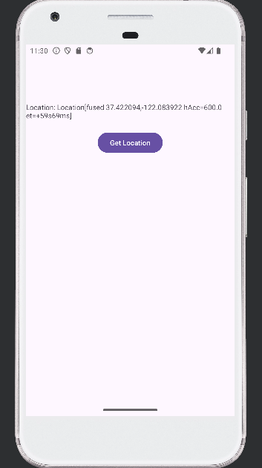

**Practical no: 17**

**Aim:- Create an Android application to Insert, Delete, Update and View the  SQL DatabaseHelper**.

Code:-

**Activity_main.xml**

*<?***xml version="1.0" encoding="utf-8"***?>*

<**LinearLayout xmlns:android="http://schemas.android.com/apk/res/android" android:layout_width="match_parent"**

**android:layout_height="match_parent"**

**android:background="#BAE4F6"**

**android:orientation="vertical"**>

<**EditText**

**android:id="@+id/text1"**

**android:layout_width="100dp"**

**android:layout_height="50dp"**

**android:hint="Name"**

**android:textSize="15sp"** />

<**EditText**

**android:id="@+id/text2"**

**android:layout_width="100dp"**

**android:layout_height="50dp"**

**android:hint="Surname"**

**android:textSize="15sp"** />

<**EditText**

**android:id="@+id/text3"**

**android:layout_width="100dp"**

**android:layout_height="50dp"**

**android:hint="Marks."**

**android:textSize="15sp"** />

<**EditText**

**android:id="@+id/text4"**

**android:layout_width="100dp"**

**android:layout_height="50dp"**

**android:hint="Id"**

**android:textSize="15sp"** />

<**LinearLayout**

**android:layout_width="match_parent"**

**android:layout_height="match_parent"**

**android:background="#F67979"**>

<**Button**

**android:id="@+id/button1"**

**android:layout_width="wrap_content"**

**android:layout_height="wrap_content"**

**android:layout_marginLeft="10dp"**

**android:layout_marginRight="5dp"**

**android:text="Add"** />

<**Button**

**android:id="@+id/button2"**

**android:layout_width="wrap_content"**

**android:layout_height="wrap_content"**

**android:layout_marginRight="5dp"**

**android:text="View"** />

<**Button**

**android:id="@+id/button3"**

**android:layout_width="wrap_content"**

**android:layout_height="wrap_content"**

**android:layout_marginRight="5dp"**

**android:text="Update"** />

<**Button**

**android:id="@+id/button4"**

**android:layout_width="wrap_content"**

**android:layout_height="wrap_content"**

**android:layout_marginRight="5dp"**

**android:text="Delete"** />

</**LinearLayout**>

</**LinearLayout**>

**MainActivity.java**

**package** com.example.practical_17;

**import** androidx.appcompat.app.AlertDialog;

**import** androidx.appcompat.app.AppCompatActivity;

**import** android.database.Cursor;

**import** android.os.Bundle;

**import** android.view.View;

**import** android.widget.Button;

**import** android.widget.EditText;

**import** android.widget.Toast;

**public class** MainActivity **extends** AppCompatActivity {  DatabaseHelper **myDb**;

 EditText **editName**, **editSurname**, **editMarks**, **editTextId**;  Button **btnAddData**;

 Button **btnviewAll**;

 Button **btnDelete**;

 Button **btnviewUpdate**;

@Override

**protected void** onCreate(Bundle savedInstanceState) { **super**.onCreate(savedInstanceState);

 setContentView(R.layout.***activity_main***); **myDb** = **new** DatabaseHelper(**this**);

**editName** = (EditText) findViewById(R.id.***text1***);

**editSurname** = (EditText) findViewById(R.id.***text2***);

**editMarks** = (EditText) findViewById(R.id.***text3***);

**editTextId** = (EditText) findViewById(R.id.***text4***);

**btnAddData** = (Button) findViewById(R.id.***button1***);

**btnviewAll** = (Button) findViewById(R.id.***button2***);

**btnviewUpdate** = (Button) findViewById(R.id.***button3***); **btnDelete** = (Button) findViewById(R.id.***button4***);

 AddData();

 viewAll();

 UpdateData();

 DeleteData();

 }

**public void** DeleteData() {

**btnDelete**.setOnClickListener(

**new** View.OnClickListener() {

@Override

**public void** onClick(View v) {

 Integer deletedRows =

**myDb**.deleteData(**editTextId**.getText().toString());

**if** (deletedRows >0)

 Toast.*makeText*(MainActivity.**this**, **"Data  Deleted"**,

 Toast.***LENGTH_LONG***).show(); **else**

Toast.*makeText*(MainActivity.**this**, **"Data not Deleted"**,  Toast.***LENGTH_LONG***).show();  }

 }

 );

 }

**public void** UpdateData() {

**btnviewUpdate**.setOnClickListener(

**new** View.OnClickListener() {

@Override

**public void** onClick(View v) {

**boolean** isUpdate = **myDb**.updateData(**editTextId**.getText().toString(), **editName**.getText().toString(),

**editSurname**.getText().toString(), **editMarks**.getText().toString()); **if** (isUpdate == **true**)

 Toast.*makeText*(MainActivity.**this**, **"Data  Update"**,

 Toast.***LENGTH_LONG***).show(); **else**

Toast.*makeText*(MainActivity.**this**, **"Data not Updated"**,  Toast.***LENGTH_LONG***).show();  }

 }

 );

 }

**public void** AddData() {

**btnAddData**.setOnClickListener(

**new** View.OnClickListener() {

@Override

**public void** onClick(View v) {

**boolean** isInserted = **myDb**.insertData(**editName**.getText().toString(), **editSurname**.getText().toString(),

**editMarks**.getText().toString());

**if** (isInserted == **true**)

 Toast.*makeText*(MainActivity.**this**, **"Data  Inserted"**,

 Toast.***LENGTH_LONG***).show(); **else**

Toast.*makeText*(MainActivity.**this**, **"Data not Inserted"**,

 Toast.***LENGTH_LONG***).show();  }

 }

 );

 }

**public void** viewAll() {

**btnviewAll**.setOnClickListener(

**new** View.OnClickListener() {

@Override

**public void** onClick(View v) {

 Cursor res = **myDb**.getAllData();

**if** (res.getCount() == 0) {

*// show message*

showMessage(**"Error"**, **"Nothing found"**);

**return**;

 }

StringBuffer buffer = **new** StringBuffer();

**while** (res.moveToNext()) {

 buffer.append(**"Id :"** + res.getString(0) +  **"\n"**);

 buffer.append(**"Name :"** + res.getString(1) +  **"\n"**);

 buffer.append(**"Surname :"** + res.getString(2) +  **"\n"**);

 buffer.append(**"Marks :"** + res.getString(3) +  **"\n\n"**);

 }

showMessage(**"Data"**, buffer.toString());

 }

 }

 );

 }

**public void** showMessage(String title, String Message) {

 AlertDialog.Builder builder = **new** AlertDialog.Builder(**this**);  builder.setCancelable(**true**);

 builder.setTitle(title);

 builder.setMessage(Message);

 builder.show();

 }

}

**DatabaseHelper.java**

**package** com.example.practical17;

**import static** android.icu.lang.UProperty.***NAME***;

**import static** org.xmlpull.v1.XmlPullParser.***TEXT***;

**import static** java.sql.Types.***INTEGER***;

**import** android.content.ContentValues;

**import** android.database.Cursor;

**import** android.database.sqlite.SQLiteDatabase;

**import** android.database.sqlite.SQLiteOpenHelper;

**import** android.content.Context;

**public class** DatabaseHelper **extends** SQLiteOpenHelper {

**public static final** String ***DATABASE_NAME*** = **"Student.db"**;

**public static final** String ***TABLE_NAME*** = **"student_table"**;

**public static final** String ***COL_1*** = **"ID"**;

**public static final** String ***COL_2*** = **"NAME"**;

**public static final** String ***COL_3*** = **"SURNAME"**;

**public static final** String ***COL_4*** = **"MARKS"**;

**public** DatabaseHelper(Context context) {

**super**(context, ***DATABASE_NAME***, **null**, 1);

 }

@Override

**public void** onCreate(SQLiteDatabase db) {

 db.execSQL(**"create table "** + ***TABLE_NAME*** + **" (ID INTEGER PRIMARY KEY  AUTOINCREMENT,NAME TEXT,Surname TEXT,Marks INTEGER)"**);

 }

@Override

**public void** onUpgrade(SQLiteDatabase db, **int** i, **int** i1) {

 db.execSQL(**"DROP TABLE IF EXISTS "** + ***TABLE_NAME***);

 onCreate(db);

 }

**public boolean** insertData(String name, String surname, String marks) {  SQLiteDatabase db = **this**.getWritableDatabase();

 ContentValues contentValues = **new** ContentValues();  contentValues.put(***COL_2***, name);

 contentValues.put(***COL_3***, surname);

 contentValues.put(***COL_4***, marks);

**long** result = db.insert(***TABLE_NAME***, **null**, contentValues);

**if** (result == -1)

**return false**;

**else**

**return true**;

 }

**public** Cursor getAllData() {

 SQLiteDatabase db = **this**.getWritableDatabase();

 Cursor res = db.rawQuery(**"select * from "** + ***TABLE_NAME***, **null**); **return** res;

 }

**public boolean** updateData(String id, String name, String surname, String  marks) {

 SQLiteDatabase db = **this**.getWritableDatabase();

 ContentValues contentValues = **new** ContentValues();  contentValues.put(***COL_1***, id);

 contentValues.put(***COL_2***, name);

 contentValues.put(***COL_3***, surname);

 contentValues.put(***COL_4***, marks);

 db.update(***TABLE_NAME***, contentValues, **"ID = ?"**, **new** String[]{id}); **return true**;

 }

**public** Integer deleteData(String id) {

 SQLiteDatabase db = **this**.getWritableDatabase(); **return** db.delete(***TABLE_NAME***, **"ID = ?"**, **new** String[]{id});  }

}

Output:-

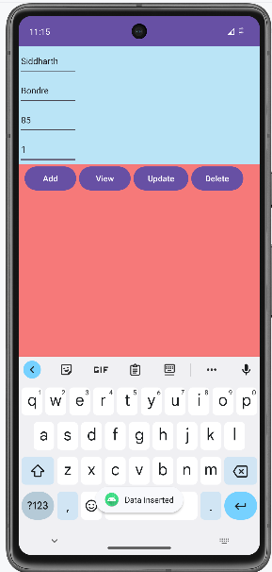 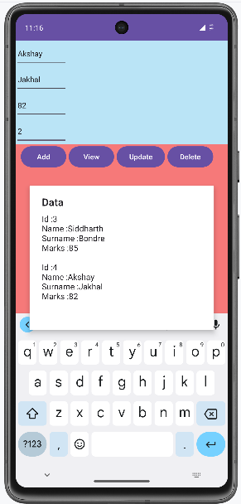

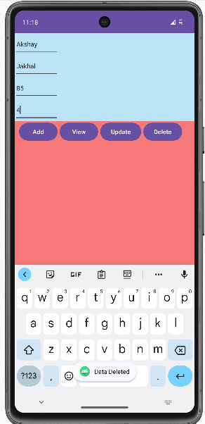 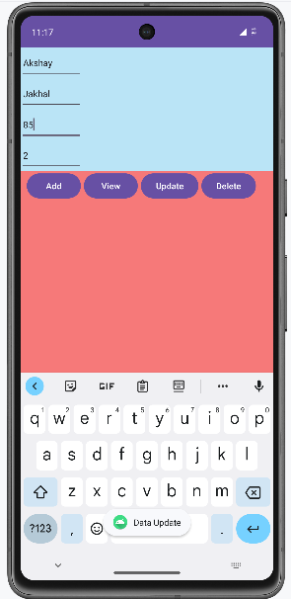

**Practical no: 18**

**Aim:- Create an Android Application to download an image using HTTPURL Connection.**

Code:-

**Activity_main.xml**

<androidx.constraintlayout.widget.ConstraintLayout xmlns:android="http://schemas.android.com/apk/res/android"  
 xmlns:app="http://schemas.android.com/apk/res-auto"  
 xmlns:tools="http://schemas.android.com/tools"  
 android:layout_width="match_parent"  
 android:layout_height="match_parent"  
 tools:context=".MainActivity">  
  
 <TextView  
 android:id="@+id/textView"  
 android:layout_width="wrap_content"  
 android:layout_height="wrap_content"  
 android:layout_alignParentTop="true"  
 android:layout_centerHorizontal="true"  
 android:text="Web Page Image"  
 android:textSize="25sp"  
 app:layout_constraintBottom_toBottomOf="parent"  
 app:layout_constraintEnd_toEndOf="parent"  
 app:layout_constraintHorizontal_bias="0.486"  
 app:layout_constraintStart_toStartOf="parent"  
 app:layout_constraintTop_toTopOf="parent"  
 app:layout_constraintVertical_bias="0.21" />  
  
 <ImageView  
 android:id="@+id/imageView"  
 android:layout_width="205dp"  
 android:layout_height="262dp"  
 android:layout_below="@+id/textView"  
 android:layout_centerHorizontal="true"  
 app:layout_constraintBottom_toBottomOf="parent"  
 app:layout_constraintEnd_toEndOf="parent"  
 app:layout_constraintStart_toStartOf="parent"  
 app:layout_constraintTop_toTopOf="parent"  
 app:layout_constraintVertical_bias="0.577" />  
  
 <Button  
 android:id="@+id/button"  
 android:layout_width="wrap_content"  
 android:layout_height="wrap_content"  
 android:layout_centerInParent="true"  
 android:text="Download"  
 android:textAppearance="@style/TextAppearance.AppCompat.Display1"  
 app:layout_constraintBottom_toBottomOf="parent"  
  
  
 app:layout_constraintEnd_toEndOf="parent"  
 app:layout_constraintStart_toStartOf="parent"  
 app:layout_constraintTop_toTopOf="parent"  
 app:layout_constraintVertical_bias="0.863" />  
</androidx.constraintlayout.widget.ConstraintLayout>

**MainActivity.java**

package com.example.practical_16;  
  
  
import androidx.appcompat.app.AppCompatActivity;  
import android.app.ProgressDialog;  
import android.content.Context;  
import android.graphics.Bitmap;  
import android.graphics.BitmapFactory;  
import android.net.ConnectivityManager;  
import android.net.NetworkCapabilities;  
import android.net.NetworkInfo;  
import android.os.Bundle;  
import android.os.Handler;  
import android.os.Message;  
import android.view.View;  
import android.widget.Button;  
import android.widget.ImageView;  
import android.widget.Toast;  
import java.io.IOException;  
import java.io.InputStream;  
import java.net.HttpURLConnection;  
import java.net.MalformedURLException;  
import java.net.URL;  
import java.net.URLConnection;  
  
public class MainActivity extends AppCompatActivity {  
  
 private ProgressDialog progressDialog;  
 private Bitmap bitmap = null;  
 Button b1;  
  
 @Override  
 protected void onCreate(Bundle savedInstanceState) {  
 super.onCreate(savedInstanceState);  
 setContentView(R.layout.*activity_main*);  
  
 b1 = findViewById(R.id.*button*);  
 b1.setOnClickListener(new View.OnClickListener() {  
 @Override  
 public void onClick(View v) {  
 if (checkInternetConnection()) {  
 downloadImage("https://hips.hearstapps.com/hmg-prod.s3.amazonaws.com/images/2022-chevrolet-corvette-z06-1607016574.jpg?crop=0.737xw:0.738xh;0.181xw,0.218xh&resize=980:*");  
 }  
 }  
 });  
 }  
  
 private void downloadImage(String urlStr) {  
 progressDialog = ProgressDialog.*show*(this, "", "Downloading Image from " + urlStr);  
  
 final String url = urlStr;  
 new Thread() {  
 public void run() {  
 InputStream in = null;  
 Message msg = Message.*obtain*();  
 msg.what = 1;  
  
 try {  
 in = openHttpConnection(url);  
 bitmap = BitmapFactory.*decodeStream*(in);  
 Bundle b = new Bundle();  
 b.putParcelable("bitmap", bitmap);  
 msg.setData(b);  
 in.close();  
 } catch (Exception e1) {  
 e1.printStackTrace();  
 }  
  
 messageHandler.sendMessage(msg);  
 }  
 }.start();  
 }  
  
 private InputStream openHttpConnection(String urlStr) throws IOException {  
 InputStream in = null;  
 int resCode;  
  
 URL url = new URL(urlStr);  
 URLConnection urlConn = url.openConnection();  
  
 if (!(urlConn instanceof HttpURLConnection)) {  
 throw new IOException("URL is not an Http URL");  
 }  
  
 HttpURLConnection httpConn = (HttpURLConnection) urlConn;  
 httpConn.setAllowUserInteraction(false);  
 httpConn.setInstanceFollowRedirects(true);  
 httpConn.setRequestMethod("GET");  
 httpConn.connect();  
  
 resCode = httpConn.getResponseCode();  
 if (resCode == HttpURLConnection.*HTTP_OK*) {  
 in = httpConn.getInputStream();  
 }  
 return in;  
 }  
  
 private final Handler messageHandler = new Handler() {  
 public void handleMessage(Message msg) {  
 super.handleMessage(msg);  
 ImageView img = findViewById(R.id.*imageView*);  
 img.setImageBitmap((Bitmap) (msg.getData().getParcelable("bitmap")));  
 progressDialog.dismiss();  
 }  
 };  
  
 private boolean checkInternetConnection() {  
 ConnectivityManager connec = (ConnectivityManager) getSystemService(Context.*CONNECTIVITY_SERVICE*);  
  
 if (connec != null) {  
 NetworkCapabilities capabilities = connec.getNetworkCapabilities(connec.getActiveNetwork());  
 if (capabilities != null &&  
 (capabilities.hasTransport(NetworkCapabilities.*TRANSPORT_WIFI*) || capabilities.hasTransport(NetworkCapabilities.*TRANSPORT_CELLULAR*))) {  
 Toast.*makeText*(this, "Connected", Toast.*LENGTH_LONG*).show();  
 return true;  
 } else {  
 Toast.*makeText*(this, "Not Connected", Toast.*LENGTH_LONG*).show();  
 }  
 }  
 return false;  
 }  
}

**AndroidManifest.xml**

<?xml version="1.0" encoding="utf-8"?>

<manifest xmlns:android="http://schemas.android.com/apk/res/android"

package="com.example.practical22">

<uses-permission android:name="android.permission.INTERNET"/>

<uses-permission android:name="android.permission.ACCESS_NETWORK_STATE" />

<application

android:allowBackup="true"

android:icon="@mipmap/ic_launcher"

android:label="@string/app_name"

android:roundIcon="@mipmap/ic_launcher_round"

android:supportsRtl="true"

android:theme="@style/Theme.Practical22">

<activity

android:name=".MainActivity"

android:exported="true">

<intent-filter>

<action android:name="android.intent.action.MAIN" />

<category android:name="android.intent.category.LAUNCHER" />

</intent-filter>

</activity>

</application>

</manifest>

Output:-

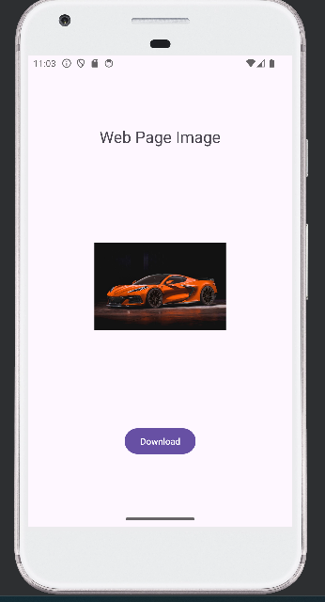

**Practical no: 19**

**Aim: Create an Android Application to accept a user name and password and redirect to next page if it is right and 3 attempt only if it is wrong**

Code:-

**activity_main.xml**

<?xml version="1.0" encoding="utf-8"?>

<RelativeLayout xmlns:android="http://schemas.android.com/apk/res/android"

xmlns:app="http://schemas.android.com/apk/res-auto"

xmlns:tools="http://schemas.android.com/tools"

android:layout_width="match_parent"

android:layout_height="match_parent"

tools:context=".MainActivity">

<EditText

android:id="@+id/et1"

android:layout_width="300dp"

android:layout_height="50dp"

android:layout_marginTop="120dp"

android:ems="10"

android:inputType="textPersonName"

android:textSize="25sp" />

<EditText

android:id="@+id/et2"

android:layout_width="300dp"

android:layout_height="50dp"

android:layout_below="@id/txt4"

android:ems="10"

android:inputType="textPassword"

android:textSize="25sp" />

<Button

android:id="@+id/button1"

android:layout_width="341dp"

android:layout_height="wrap_content"

android:layout_below="@id/et2"

android:layout_centerHorizontal="true"

android:layout_marginBottom="200dp"

android:text="Login"

android:textColor="#01090F"

android:textSize="36sp" />

<TextView

android:id="@+id/txt3"

android:layout_width="wrap_content"

android:layout_height="wrap_content"

android:layout_marginTop="85dp"

android:text="User Name"

android:textSize="25sp" />

<TextView

android:id="@+id/txt4"

android:layout_width="wrap_content"

android:layout_height="wrap_content"

android:layout_below="@id/et1"

android:text="Password"

android:textSize="25sp" />

</RelativeLayout>

**MainActivity.java**

package com.example.practical20;

import androidx.appcompat.app.AlertDialog;

import androidx.appcompat.app.AppCompatActivity;

import android.content.DialogInterface;

import android.content.Intent;

import android.os.Bundle;

import android.view.View;

import android.widget.Button;

import android.widget.EditText;

public class MainActivity extends AppCompatActivity {

Button button1;

EditText et1, et2;

String username, password;

int attempt_counter;

@Override

protected void onCreate(Bundle savedInstanceState) {

super.onCreate(savedInstanceState);

setContentView(R.layout.activity_main);

button1 = (Button) findViewById(R.id.button1);

et1 = (EditText) findViewById(R.id.et1);

et2 = (EditText) findViewById(R.id.et2);

button1.setOnClickListener(new View.OnClickListener() {

@Override

public void onClick(View view) {

username = et1.getText().toString();

password = et2.getText().toString();

if (username.equals("Mahek") &password.equals("123")) {

Intent intent = new Intent(MainActivity.this,

welcome.class);

String message = et1.getText().toString();

intent.putExtra("hello", message);

startActivity(intent);

} else {

attempt_counter++;

if (attempt_counter == 3) {

button1.setEnabled(false);

AlertDialog.Builder a_builder = new

AlertDialog.Builder(MainActivity.this);

a_builder.setMessage("3 attempt made")

.setCancelable(false)

.setNegativeButton("OK", new

DialogInterface.OnClickListener() {

@Override

public void onClick(DialogInterface dialog, int i) {

dialog.cancel();

}

});

AlertDialog alert = a_builder.create();

alert.setTitle("Retry!!");

alert.show();

}

AlertDialog.Builder a_builder = new

AlertDialog.Builder(MainActivity.this);

a_builder.setMessage("Incorrect username or password "

+ attempt_counter + " attempts made")

.setCancelable(false)

.setNegativeButton("OK", new

DialogInterface.OnClickListener() {

public void onClick(DialogInterface dialog, int which) {

dialog.cancel();

}

});

AlertDialog alert = a_builder.create();

alert.setTitle("Alert!!");

alert.show();

}

}

});

}

}

activity_welcome.xml

<?xml version="1.0" encoding="utf-8"?>

<RelativeLayout xmlns:android="http://schemas.android.com/apk/res/android"

xmlns:app="http://schemas.android.com/apk/res-auto"

xmlns:tools="http://schemas.android.com/tools"

android:layout_width="match_parent"

android:layout_height="match_parent"

tools:context=".welcome">

<TextView

android:id="@+id/textView"

android:layout_width="364dp"

android:layout_height="70dp"

android:layout_alignParentStart="true"

android:layout_alignParentLeft="true"

android:layout_alignParentTop="true"

android:layout_marginStart="29dp"

android:layout_marginLeft="29dp"

android:layout_marginTop="264dp"

android:textSize="30dp" />

</RelativeLayout>

**welcome.java**

package com.example.practical20;

import androidx.appcompat.app.AppCompatActivity;

import android.content.Intent;

import android.os.Bundle;

import android.widget.TextView;

public class welcome extends AppCompatActivity {

TextView textView;

@Override

protected void onCreate(Bundle savedInstanceState) {

super.onCreate(savedInstanceState);

setContentView(R.layout.activity_welcome);

setContentView(R.layout.activity_welcome);

Intent intent = getIntent();

String message = intent.getStringExtra("hello");

textView = findViewById(R.id.textView);

textView.setText("Welcome " + message);

}

}

Output:-

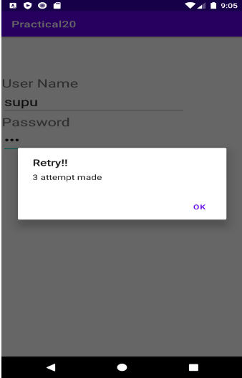 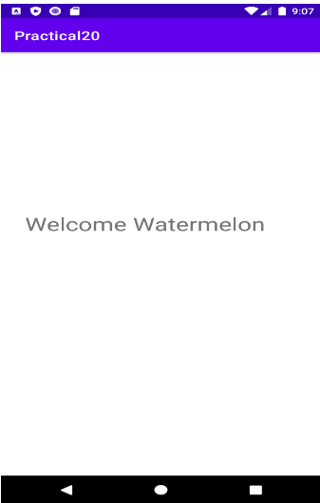

**Practical no: 20**

**Aim: Create an Android Application to read and display JSON data**

Code:-

**activity_main.xml**

<?xml version="1.0" encoding="utf-8"?>

<RelativeLayout xmlns:android="http://schemas.android.com/apk/res/android"

xmlns:app="http://schemas.android.com/apk/res-auto"

xmlns:tools="http://schemas.android.com/tools"

android:layout_width="match_parent"

android:layout_height="match_parent"

tools:context=".MainActivity">

<TextView

android:id="@+id/tv1"

android:layout_width="match_parent"

android:layout_height="wrap_content"

android:gravity="center_horizontal"

android:text="SaaP Group"

android:textAlignment="center"

android:textColor="@android:color/holo_blue_light"

android:textSize="25sp" />

<TextView

android:id="@+id/text_view_result"

android:layout_width="wrap_content"

android:layout_height="wrap_content"

android:layout_below="@+id/tv1"

android:textColor="@android:color/holo_blue_light"

android:textSize="20sp" />

<Button

android:id="@+id/button_parse"

android:layout_width="wrap_content"

android:layout_height="wrap_content"

android:layout_alignParentBottom="true"

android:layout_centerHorizontal="true"

android:layout_marginBottom="30dp"

android:text="Parse" />

</RelativeLayout>

**MainActivity.java**

package com.example.practical21;

import androidx.appcompat.app.AppCompatActivity;

import android.app.VoiceInteractor;

import android.os.Bundle;

import android.view.View;

import android.widget.Button;

import android.widget.TextView;

import com.android.volley.Request;

import com.android.volley.RequestQueue;

import com.android.volley.Response;

import com.android.volley.VolleyError;

import com.android.volley.toolbox.JsonObjectRequest;

import com.android.volley.toolbox.Volley;

import org.json.JSONArray;

import org.json.JSONException;

import org.json.JSONObject;

public class MainActivity extends AppCompatActivity {

private TextView mtext;

private RequestQueue mqueue;

@Override

protected void onCreate(Bundle savedInstanceState) {

super.onCreate(savedInstanceState);

setContentView(R.layout.activity_main);

mtext = findViewById(R.id.text_view_result);

Button buttonparse = findViewById(R.id.button_parse);

mqueue = Volley.newRequestQueue(this);

buttonparse.setOnClickListener(new View.OnClickListener() {

@Override

public void onClick(View view) {

jsonparse();

}

});

}

private void jsonparse() {

String url = "https://api.npoint.io/3864434b31deac300430";

JsonObjectRequest r = new JsonObjectRequest(Request.Method.GET,

url, null, new Response.Listener<JSONObject>() {

@Override

public void onResponse(JSONObject response) {

try {

JSONArray jsonArray =

response.getJSONArray("Student");

for (int i = 0; i < jsonArray.length(); i++) {

JSONObject student =

jsonArray.getJSONObject(i);

String password =

student.getString("password");

String name = student.getString("name");

String designation =

student.getString("designation");

mtext.append(name + ", " + designation + "\n\n");

}

} catch (JSONException e) {

e.printStackTrace();

}

}

}, new Response.ErrorListener() {

@Override

public void onErrorResponse(VolleyError error) {

error.printStackTrace();

}

});

mqueue.add(r);

}

}

**AndroidManifest.xml**

<uses-permissionandroid:name="android.permission.INTERNET"></uses-

permission>

**Build.gradel(app)**

implementation'com.android.volley:volley:1.1.0'

Output:-

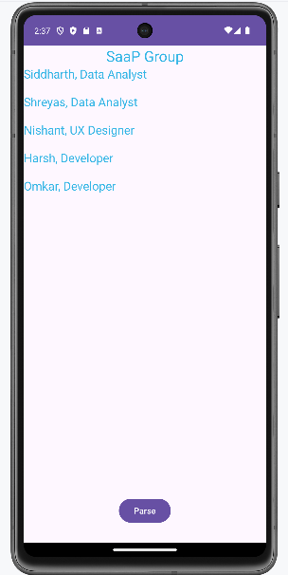

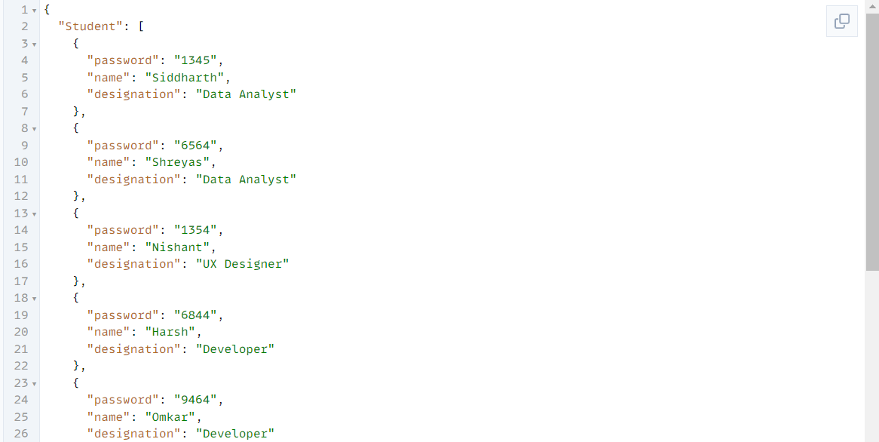

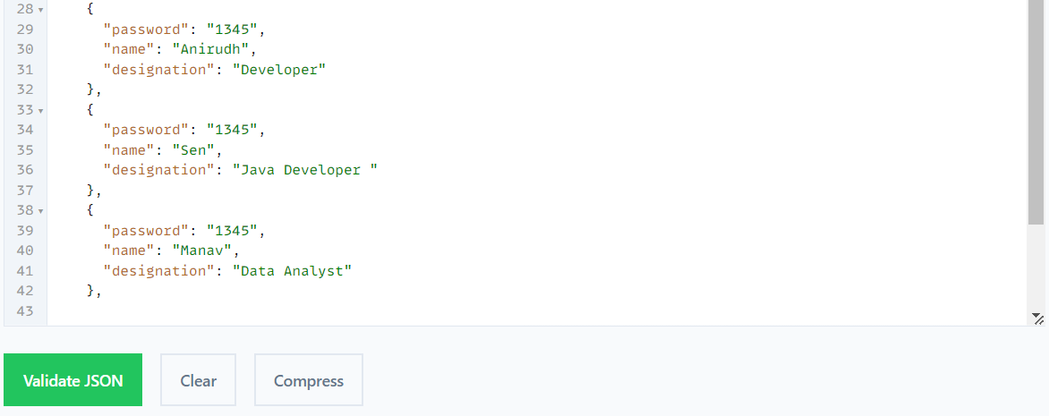

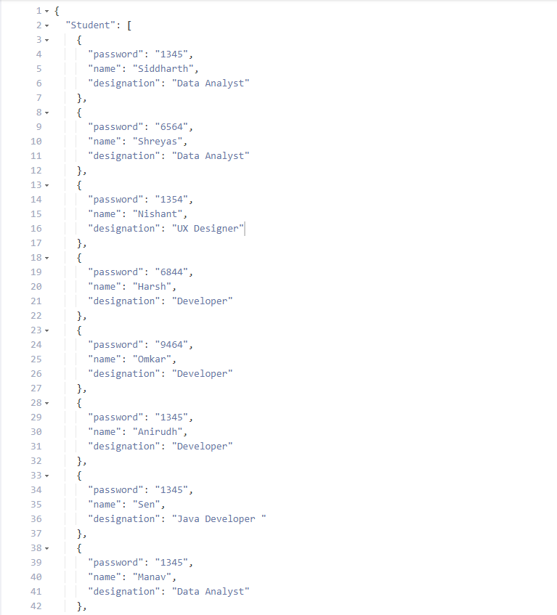

**Practical no: 21**

**Aim:- Create a Flutter Application to display the message how many times the button has been clicked**

Code:

import 'package:flutter/material.dart';  
void main() {  
  runApp(const MyApp());  
}  
class MyApp extends StatelessWidget {  
const MyApp({super.key});

@override  
  Widget build(BuildContext context) {  
return MaterialApp(  
      title: 'Flutter Demo',  
      theme: ThemeData(  
colorScheme: ColorScheme.fromSeed(seedColor: Colors.deepPurple),  
        useMaterial3: true,  
      ),  
      home: const MyHomePage(title: 'Flutter Demo Home Page'),  
    );  
  }  
}  
class MyHomePage extends StatefulWidget {  
const MyHomePage({super.key, required this.title});  
final String title;  
  @override  
  State<MyHomePage> createState() => _MyHomePageState();  
}  
class _MyHomePageState extends State<MyHomePage> {  
  int _counter = 0;  
  
void _incrementCounter() {  
    setState(() {  
_counter++;  
    });  
 }  
  @override  
  Widget build(BuildContext context) {  
returnScaffold(  
      appBar: AppBar(  
backgroundColor: Theme.of(context).colorScheme.inversePrimary,  
title: Text(widget.title),  
      ),  
      body: Center(  
child: Column(  
mainAxisAlignment: MainAxisAlignment.center,  
          children: <Widget>[  
const Text(  
'You have pushed the button this many times:',  
            ),  
            Text(  
'$_counter',  
              style: Theme.of(context).textTheme.headlineMedium,  
            ),  
          ],  
        ),  ),  
      floatingActionButton: FloatingActionButton(  
        onPressed: _incrementCounter,  
        tooltip: 'Increment',  
        child: const Icon(Icons.add),  
      ),);}}

Output:-

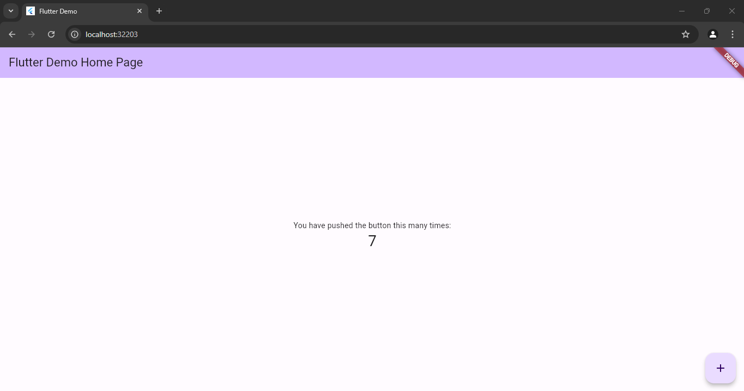

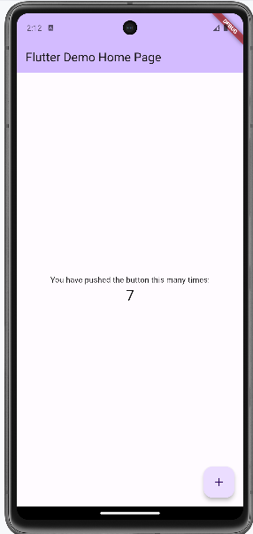

**Practical no: 22**

**Aim:- Create a Flutter Application to display the message**

Code:-

import 'package:flutter/material.dart';  
void main() {  
  runApp(const MaterialApp(  
    home:Center(child: Text(Hello Siddharth!))  
  ));  
}

Output:-

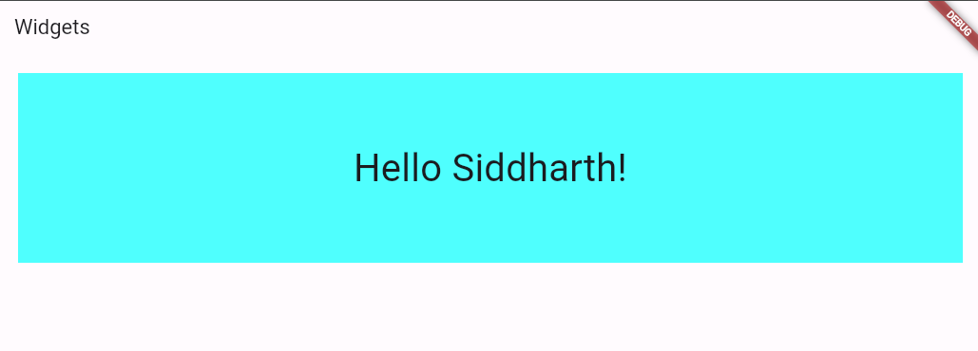

**Practical no: 23**

**AIM: Create a Flutter Application to display the ElevatedButton**

Code:-

import 'package:flutter/material.dart';

void main() {

runApp(const MyApp());

}

class MyApp extends StatelessWidget {

const MyApp({Key? key}) : super(key: key);

@override

Widget build(BuildContext context) {

return MaterialApp(

debugShowCheckedModeBanner: false,

home: Scaffold(

appBar: AppBar(

title: Text('App title'),

),

body: Center(

child: ElevatedButton(

onPressed: () {},

child: Text("Raised Button", style: TextStyle(fontSize: 20.0)),

)),

));

}

}

Output:-

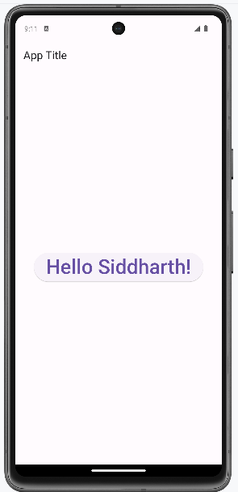

**Practical no: 24**

**Aim : Create a Flutter Application to display an image.**

Code:-

import 'package:flutter/material.dart';

void main() {

runApp(MaterialApp(

home: Scaffold(

body: Center(

child: Image.asset('assests/images/img.png')

),

),

));

}

Output:-

